Sammamish Transit Plan
Existing Conditions Report

June 2023
PREPARED FOR:
City of Sammamish

DOCUMENT DESCRIPTION
CLIENT | City of Sammamish
DKS Project / Proposal Number | 23045-000
Project /  Proposal Name | Sammamish Transit Plan
Document Name | Existing Conditions Report
Date Document Issued | June 28, 2023

Version Control
Version Number | Date | Description of Change | Author
0-1 | 06/08/2023 | Initial Document | S Keenan
0-2 | 06/28/2023 | Incorporated Comments from City of Sammamish and TAC | S Keenan

Prepared for City Of Sammamish

Prepared by DKS Associates

Table of Contents
Introduction 1
Existing Plans 1
Data Collection and Visualization 5
Existing conditions Analysis 7
COVID-19 Impacts on Sammamish Transit 7
Existing Demographics 7
Key Takeaways- Existing Demographics 7
Existing Commute Patterns 17
Key Takeaways- Existing Commute Patterns 17
Vanpools and other Alternatives 21
Existing Transit Network 21
Short-Term Transit Network Changes (2025) 25
Ridership 25
Metro Flex 27
Key Takeaways– Existing Transit Network 28
Existing Access to Transit 29
Key Takeaways – Access to Transit 35
Transit and Auto Travel Time Comparisons 35
Regional Trips 36
Local Trips 39
Key Takeaways – Transit Travel Time 42
Transit operational performance 42
Key Takeaways – Transit Operational Performance 48
Conclusion 48

LIST OF FIGURES
Figure 1: gEOGRAPHIC dISTRIBUTION OF tOTAL pOPULATION BY bLOCK 9
Figure 2: rACE/eTHNICITY bREAKDOWN IN Sammamish 10
Figure 3: gEOGRAPHIC dISTRIBUTION OF Racial Diversity BY bLOCK 11
Figure 4: GEOGRAPHIC DISTRIBUTION OF LOW-INCOME POPULATION BY BLOCK GROUP 12
Figure 5: aGE BREAKDOWN OF Sammamish pOPULATION 13
Figure 6: sENIORS 65+ lIVING IN Sammamish 13
Figure 7: Senior 65+ Sammamish Population over time 14
Figure 8: aVAILABLE vEHICLES PER Occupied hOUSING uNIT in Sammamish 14
Figure 9: gEOGRAPHIC dISTRIBUTION OF Zero Vehicle hOUSEHOLDS BY bLOCK gROUP 15
Figure 10: Geographic distribution of jobs by block group 16
Figure 11: Commute mode share within Sammamish (Including and Excluding work from Home) 18
Figure 12: Commute Travel Time by Mode for Workers Living in Sammamish 19
Figure 13: Commuters Walking, Biking, or Using Pulblic Transit in Sammamish (excluding WOrk from Home) 19
Figure 14: Geographic Distribution of Commuters taking Public Transit by Block Group 20
Figure 15: Bus routes By type and station locations, Fall 2022 23
Figure 16: Transit Ridership within Sammamish 26
Figure 17: Transit Ridership by Year 27
Figure 18: Metro Flex Service area in Sammamish 28
Figure 19: Topographical Features Near Transit Service in Sammamish 30
Figure 20: transit stops with ¼ mile and ½ mile walkshed 32
Figure 21: transit stops with 1-mile bikeshed 33
Figure 22: Park and Ride with driveshed 34
Figure 23: Travel Time Comparisons for Sample Regional Trips to/From Sammamish, Ratio of Scheduled Transit to Projected Auto Time at Tuesday, 7 AM from Sammamish 4 pm to Sammamish based on Google Trip Planner 37
Figure 24: Travel Time Comparisons for Sample Local trips within Sammamish, Ratio of Scheduled Transit to Projected Auto Time at Tuesday, 4 pm based on Google Trip Planner 40
Figure 25: Map of Bus Segment Delay Route 216 44
Figure 26: Map of Bus Segment Delay Route 269 45
Figure 27: Map of Passenger Delay Route 216 46
Figure 28: Map of Passenger Delay Route 269 47

LIST OF TABLES
Table 1 Weekday Transit Routes Overview, fall 2016, 2019 and 2022 24
Table 2 Anticipated 2025 Service Changes in Sammamish 25
Table 3 Walkshed Demographicsand Jobs Data (2020) 31
Table 4 REGIONAL TRANSIT AND AUTO TRAVEL TIME COMPARISONS 38
Table 5 Transit Travel Times between Origin-Destination Pairs, Transit Travel Time and TraNsit-To-Auto Travel Time Ratio 41

Glossary
Alighting
Dismounting from a vehicle
Headway
The average time between buses on the same route
Ridership
The average number of passengers using a route

Introduction
The purpose of the report is to document and analyze the existing conditions within Sammamish to establish an understanding of how the current public transportation network is serving the public. This report provides data and analysis related to transportation, demographics, regional travel patterns, the transit services currently available, and how those services operate and perform.
First, the project team reviewed previously published plans from the City of Sammamish, King County Metro, Sound Transit, and Puget Sound Regional Council (PSRC) to gain an understanding of forthcoming projects and stated policy goals as it relates to transit. Next, demographic and commute trends such as mode share were evaluated using publicly available Census data. Finally, the existing transit network was analyzed with regards to existing coverage, ridership, performance, and access.

Existing Plans
The project team studied existing plans from the City, King County Metro, Sound Transit, and PSRC to review upcoming projects, future planned changes in transit service within Sammamish and the surrounding region, stated policy goals related to transit performance, and previously completed analysis of the existing and future network. A summary of relevant information from these plans is presented below.
- City of Sammamish Transportation Improvement Plan (TIP)
  - The City’s TIP includes several planned transportation projects along existing transit corridors. These projects include:
    - Issaquah-Pine Lake Road Widening – The existing two-lane cross-section will be widened to allow for an urban three-lane cross section with curb, gutter, sidewalks, bike lanes, landscape strips, center turn lanes, and raised landscaped center median in certain locations. The project also includes a new signal with crosswalk at SE 37th Place. The limits of the project are from SE 32nd Way to SE 44th Street. Design for this project is expected to be completed in 2029.
    - Sahalee Way Widening – The existing two-lane cross-section will be widened to allow for a three-lane street section with one travel lane in each direction, center median island or turn lanes, bike lanes, planter strips, and sidewalks. Signalization is also being considered for NE 28th Place at 223rd Avenue NE and Sahalee Way at NE 36th Street. The limits of the project are from SE 25th Way to the northern city boundary. 30% design for this project is expected to be completed in 2024.
- PSRC Regional Transportation Plan
  - The Puget Sound Regional Transportation Plan (RTP) was adopted by the General Assembly on May 26, 2022. The RTP sets forth the framework for achieving the policy goals detailed in the VISION 2050. Selected regional modeling outputs for the 2050 horizon year related to transit include:
    - 59% of households will be within ½ mile of an integrated high-capacity transit (HCT) system, and transit ridership is expected to more than triple by 2050.
    - Areas with higher concentrations of people of color and people with low incomes will have higher rates of access to high-capacity transit (82% and 79% respectively) compared to the regional average (59%).
    - Households on average will experience a 15% reduction in annual vehicle hours of delay from 2018.
    - Average household vehicle miles traveled (VMT) are reduced by 23%.
    - Growth in transit trips will be 82% between 2018 and 2050.
    - The average person in the region is forecast to spend about 34 minutes each day traveling, a 15% reduction compared to 2018.
    - Single-occupancy vehicle (SOV) mode shares to work are forecast to decrease from approximately 65% in 2018 to approximately 52% from 2018.
    - Walking, biking, and transit will constitute 32% of all work trips, an increase from 17% in 2018.
  - In 2018, 83% of trips accessing transit did so through non-motorized modes travel (biking or walking). Furthermore approximately 25% of people in the region lived within ½ mile of a high-capacity transit station.
  - High-capacity transit modes provided approximately 25% of the region’s transit boardings in 2018.
  - PSRC’s regional plan for growth, VISION 2050, calls for attracting 65% of the region’s residential growth and 75% of its employment growth to regional geographies that are centered upon high-capacity transit station areas. This is referred to as transit-oriented developed (TOD).
  - The Coordinated Mobility Plan constitutes Appendix B of PSRC’s RTP. This plan provides a planning framework and implementation strategy for the development of transportation services for people with special transportation needs. Specific groups include older adult and youth populations, people with disabilities, and low-income households. This plan includes an inventory of existing specialized transportation services such as ADA Paratransit, Non-Emergency Medical Transportation, and Travel Training. The Coordinated Mobility Plan also includes several strategies for targeting mobility and access improvements for those with special transportation needs including the expansion of paratransit and other on-demand services, building more ADA-compliant infrastructure, and enhancements to regional coordination across various organizations.
  - Appendix D2 of the RTP is the Regional Capacity Project List. Included in this document are two transportation improvement projects within Sammamish which are labeled as “candidate” which means they have not yet been approved within the Metropolitan Transportation Plan (MTP). The two projects are as follows:
    - 228th Ave SE Capacity Improvements – This project includes widening 228th Ave SE to five lanes along with adding striped or buffered bike lanes, curb, gutter and sidewalk/boardwalk, intersection improvements at SE 40th St, and signalization of the Providence Heights Loop intersection. The Regional Capacity List estimates that the project will be completed in 2026, but project scoping, timing, and budget have not yet been determined.
    - Sahalee Way NE Capacity Improvements – This project includes widening Sahalee Way NE to three to five lanes along with adding buffered bike lanes, curb, gutter, sidewalk, intersections improvements, and signalization of the NE 28th Place intersection. It is estimated that the project will be completed in 2030. This project is also included in the City’s TIP. A corridor study is planned for 2024 to allow the City to determine the improvements necessary for this corridor.
- King County Metro’s Metro Connects
  - Metro Connects, adopted in January 2017 and updated in November 2021, is King County Metro’s long-range plan for system improvement and expansion for 2050. The plan, which is not fully funded, calls for a more than 70 percent increase in service by 2050. If fully implemented, the plan projects a 15-20% reduction in per capita VMT throughout the region.
    - The plan calls for target time savings goals categorized by type of service. These goals are as follows:
      - New RapidRide – 20%+ time savings
      - Existing RapidRide – 10-15% time savings
      - Frequent – 10-15% time savings
      - Express – 5-10% time savings
      - Local – 3-5% time savings
    - Travel time reductions can be achieved through infrastructure investments such as Business Access and Transit (BAT) lanes and transit signal priority and through technology such as more efficient fare payment systems.
    - The plan supports transit-oriented communities (TOCs) and transit-oriented development (TODs) to support transit use through higher density development patterns.
    - Metro has identified key performance measures to assess its service and align with their strategic vision. These include but are not limited to ridership, ORCA transfers, proximity to transit, and VMT.
- Sound Transit’s ST3 Plan
  - Sound Transit’s Regional Transit System Plan for the Central Puget Sound region was first completed in June 2016 and was subsequently revised in a realignment plan which was adopted in August 2021. The ST3 plan proposes an expansion and improvement of Sound Transit’s existing service.
    - Light Rail
      - Extend light rail from S Kirkland to Issaquah.
      - Extend light rail from Kent/Des Moines to Federal Way.
      - Extend light rail from Angle Lake to Kent/Des Moines.
      - Extend light rail from Federal Way to Tacoma and between downtown Seattle to West Seattle.
      - Extend light rail between downtown Seattle and Ballard.
      - Extend light rail from Lynnwood to Everett via the Southwest Everett Industrial Center.
      - Extend light rail from Tacoma Link to Tacoma Community College.
      - Extend light rail on the Eastside connecting Redmond, Bellevue, south Kirkland, and Issaquah to each other and the rest of the light rail network.
    - Bus Rapid Transit (BRT)
      - Establish BRT service on the I-405 from the Lynnwood Transit Center to the Tukwila International Boulevard light rail station, and from there via SR 518 to the Burien Transit Center.
      - A new transit center will be added in south Renton.
      - BRT service using BAT lanes on SR 522, connecting Link light rail station in Shoreline and I-405 BRT service near University of Washington Bothell.
    - Other bus improvement investments such as traffic signal and bus priority improvements on Madison Street BRT.
    - Commuter Rail
      - Extend Sounder commuter rail service during peak hours from Lakewood to new stations at Tillicum and DuPont.
    - North Sammamish Park and Ride
      - The project is intended to provide up to 200 parking spaces
      - The Park and Ride is expected to be located in the northern part of the City of Sammamish.
      - The total budget for this project is $20M, which includes all phases of the project from planning, design, property acquisition, construction and administrative costs.
      - On August 5, 2021, the Sound Transit Board delayed the opening of the park and ride to 2045.

Data Collection and Visualization
The project team utilized two data collection tools in this report. The first is data from the King County Metro Speed and Reliability dashboard which aggregates existing transit performance measures such as passenger delay within King County across multiple transit routes. The second data source is MySidewalk, a platform which allows publicly available data such as the US Census to be easily visualized across selected geographies.
- King County Metro Speed and Reliability Planning Dashboard
  - King County Metro developed an analytic dashboard to help diagnose speed and reliability issues throughout the bus system and evaluate the benefits and costs of various bus speed and reliability investments. Data from this dashboard was used to provide metrics such as bus delay and passenger delay that are presented in this report.
- MySidewalk
  - MySidewalk is a platform which pulls together publicly available data such as the US Census and the American Community Survey (ASC) to produce tables and visualizations for specific geographies. The ACS is an ongoing survey conducted by the Census Bureau. The survey continues all year, every year with randomly sampled addresses in every state. Relevant survey questions include demographic data and journey to work data. The project team used MySidewalk to analyze demographic trends for Sammamish, at the census block group level where appropriate and feasible.

Existing conditions Analysis
This section covers the analysis of existing demographics and commute patterns of Sammamish. In addition, this section includes an analysis of current transit operations, access to transit, travel time competitiveness as it relates to mode choice, equity considerations, and operational performance.

COVID-19 Impacts on Sammamish Transit
The COVID-19 pandemic had significant impacts on transportation within Sammamish. This report explores existing conditions, and that is generally defined as 2021-2023, depending on available data. COVID-19 had significant impacts on transit ridership in the Puget Sound region, including Sammamish. As seen in Figure 17, transit ridership in Sammamish was about 50% higher in 2019 compared with 2022. In 2020, King County Metro permanently suspended Route 219, and added the Community Ride service in Sammamish, now known as Metro Flex. Metro Flex is discussed in detail later in this report. The decrease in ridership trend is also shown in the South Sammamish Park and Ride occupancy data. In 2019, the park and ride was about 54% full on the average weekday, and it reduced to only 2% in 2021. The share of workers who worked from home in Sammamish increased during this time from 9.7% in 2019 to 24.6% in 2021.

Existing Demographics
This section provides an overview of the current demographic characteristics in Sammamish. US Census and ACS data was pulled from the MySidewalk platform to gain an understanding of both people-centered demographic attributes such as race/ethnicity and income level and transportation-related attributes including modal split and average commute times. This analysis will allow for a deeper understanding of how the existing transportation network is serving the community in an equitable manner.

Key Takeaways- Existing Demographics
There were 66,531 people living in Sammamish as of 2021. Figure 1 shows that most of Sammamish has less than 5,000 people per square mile. The areas of highest population density are generally located in the Klahanie neighborhood. The Klahanie neighborhood is bound by Issaquah-Pine Lake Road SE and SE 32nd Street in the southeast corner of the City.
Figure 2 shows a breakdown of the percentage of the total population by self-reported ethnicity. In summary, 54.5% of the total population is White. For comparison, in King County as a whole, 63.5% of the total population is White. The second largest ethnic group in Sammamish is Asian at 33.3%, followed by two or more races at 5.9%. As shown in Figure 3, people of color are most concentrated in a block group at the northernmost portion of the city. People of color are well distributed across the city, with most block groups having at least 30% people of color.
Figure 4 illustrates that the majority of block groups in Sammamish have less than 5% of the population qualifying as low-income, which is defined by the federal poverty level. The area of highest concentration of people with low income is the Klahanie neighborhood. Overall, 3.1% of Sammamish is considered to be in poverty, compared with 9.3% overall in King County.
Sammamish tends to have a younger population with more families than King County on average. Figure 5 shows that 6.1% of the population in Sammamish are children under the age of 5, compared with 5.2% for King County overall. In Sammamish, 29.6% of the population are under the age of 18, compared with 19.2% in King County overall. As depicted in Figure 6, 7.8% of the population of Sammamish is aged 65 years or older, compared with 14.2% of the population of King County. The percentage of the population over the age of 65 has more than doubled in the past two decades, as shown in Figure 7.
As shown in Figure 8, citywide, the proportion of households with one available vehicle is 11.6%, while 87.2% of households have two or more available vehicles. For comparison, in King County, on average 27.9% of households have one vehicle available, while 66.1% of households have two or more available vehicles. Zero vehicle households comprise 1.2%, compared with 6% county-wide. In Sammamish, these households are most concentrated in a block group at the northernmost portion of the city as shown in Figure 9; however, there are some of these households in most census block groups within the city. It is important to note that the geographic distribution of zero vehicle households does not have a strong correlation with the distribution of low-income populations.
Figure 10 shows where the highest concentration of low-paying jobs is within the city. These areas coincide with the three retail shopping centers within Sammamish – Sammamish Highlands, Pine Lake Village, and Klahanie.
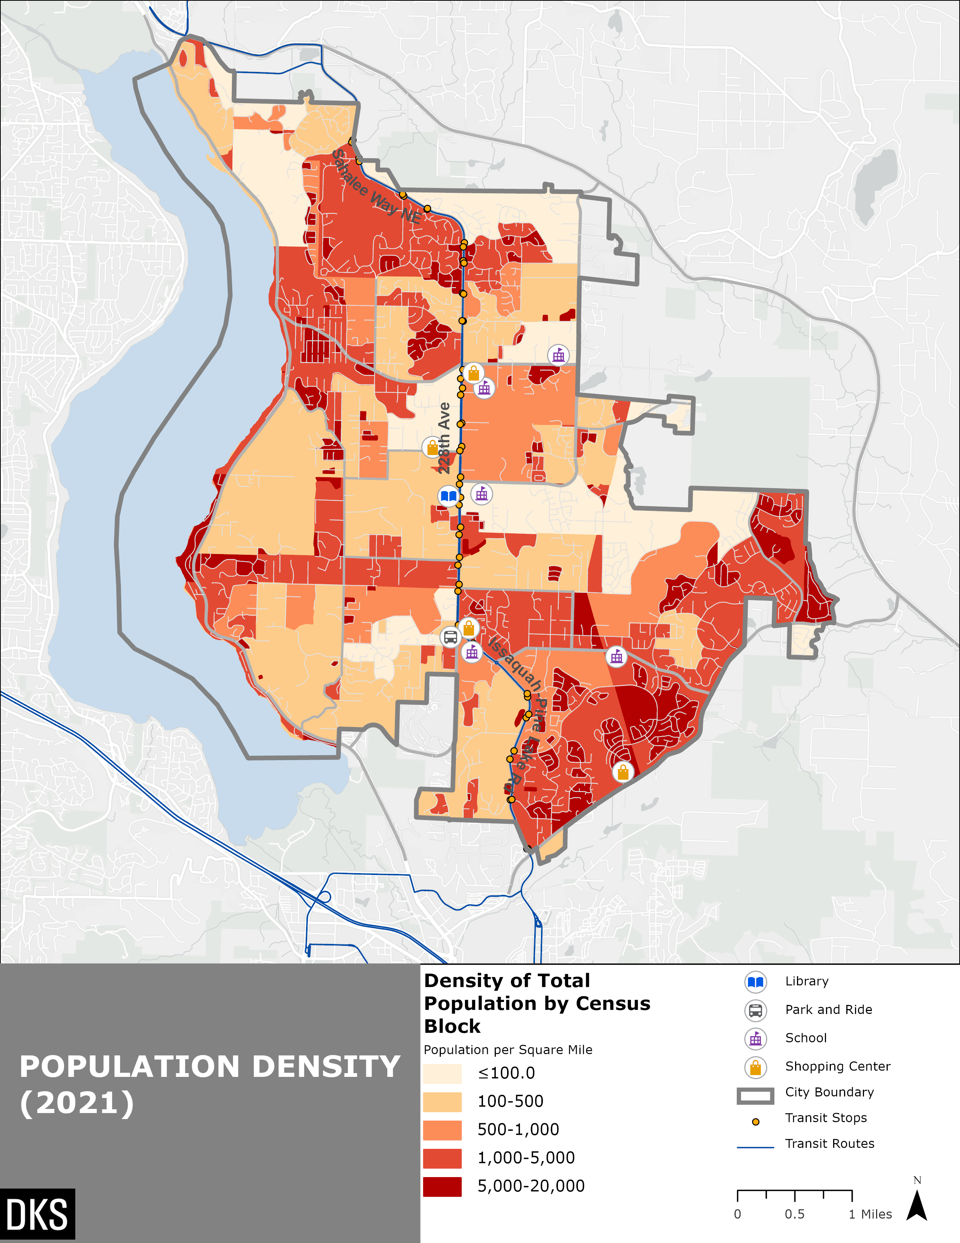
Figure 1: gEOGRAPHIC dISTRIBUTION OF tOTAL pOPULATION BY bLOCK
Source: US Census 2021
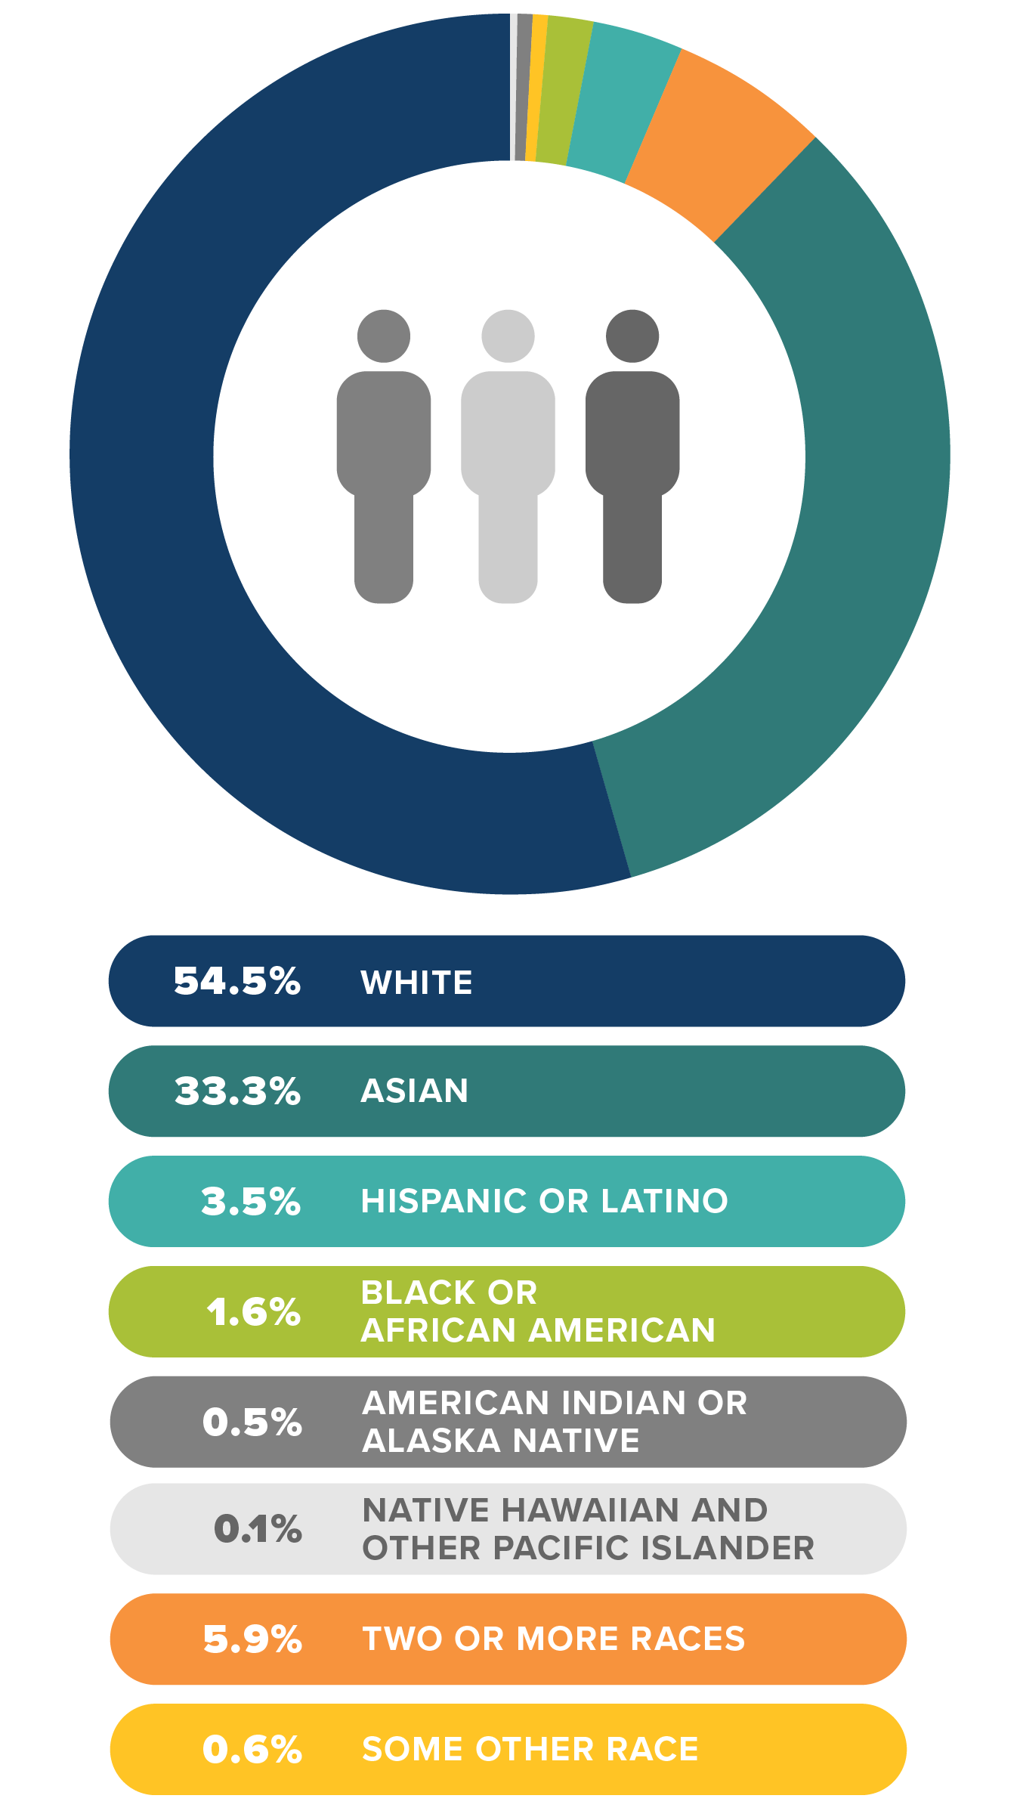
Figure 2: rACE/eTHNICITY bREAKDOWN IN Sammamish
Source: US Census 2021
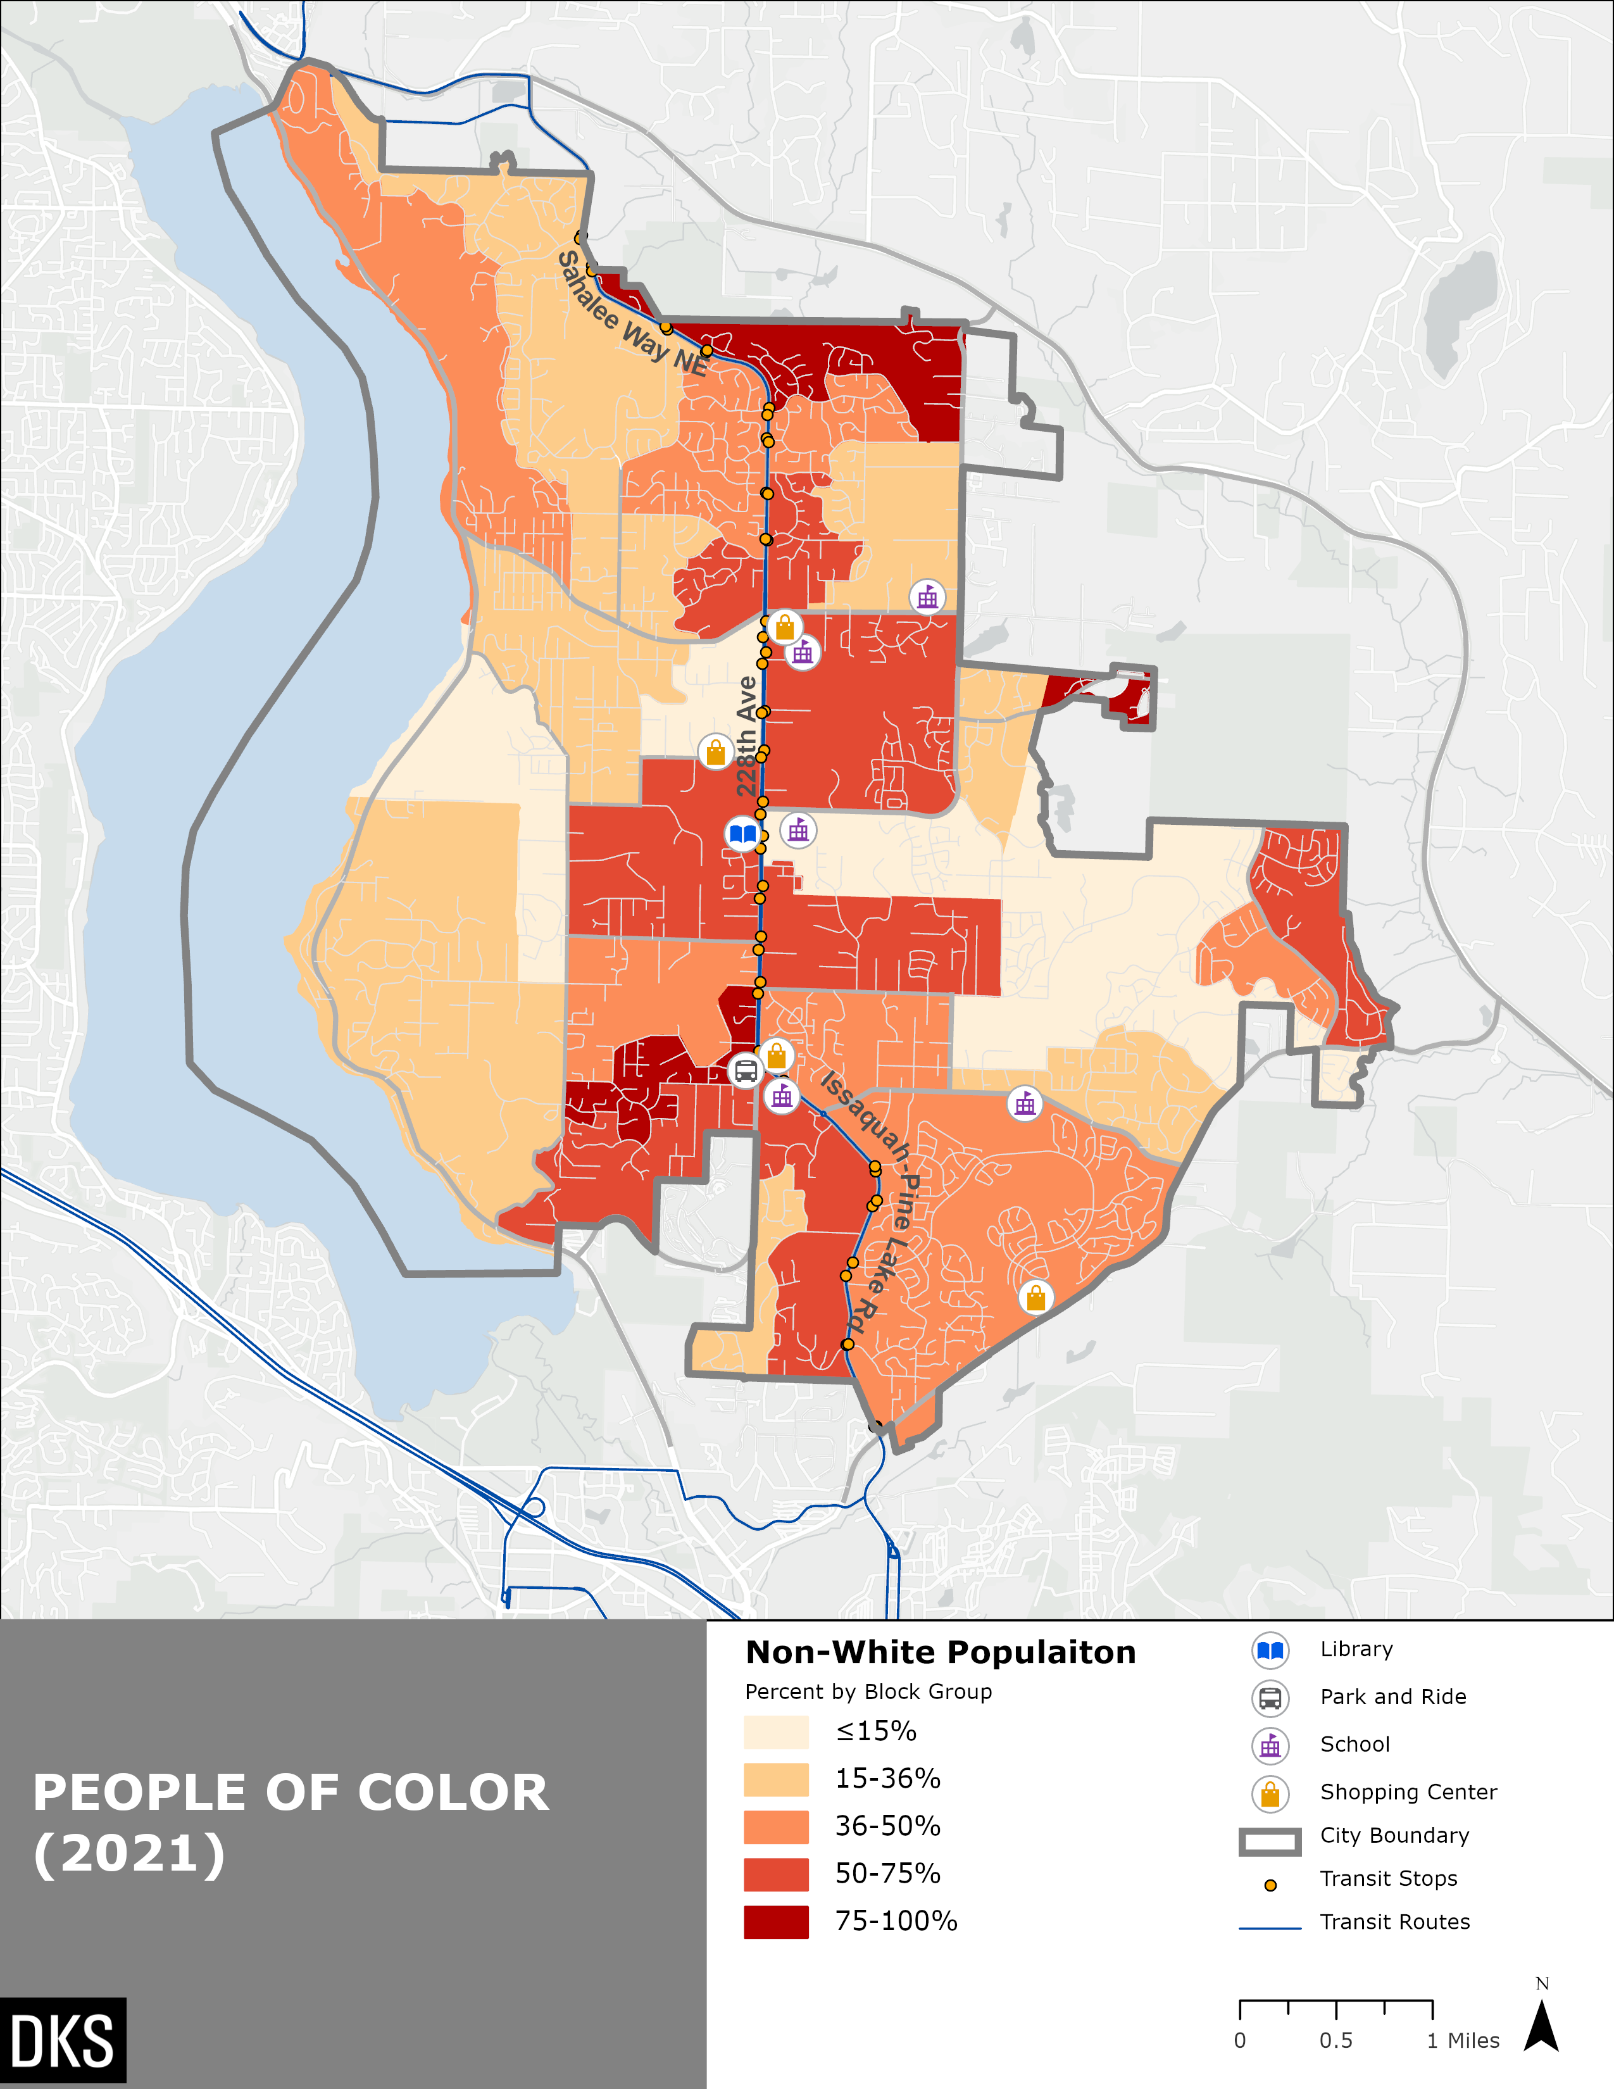
Figure 3: gEOGRAPHIC dISTRIBUTION OF Racial Diversity BY bLOCK
Source: US Census 2021
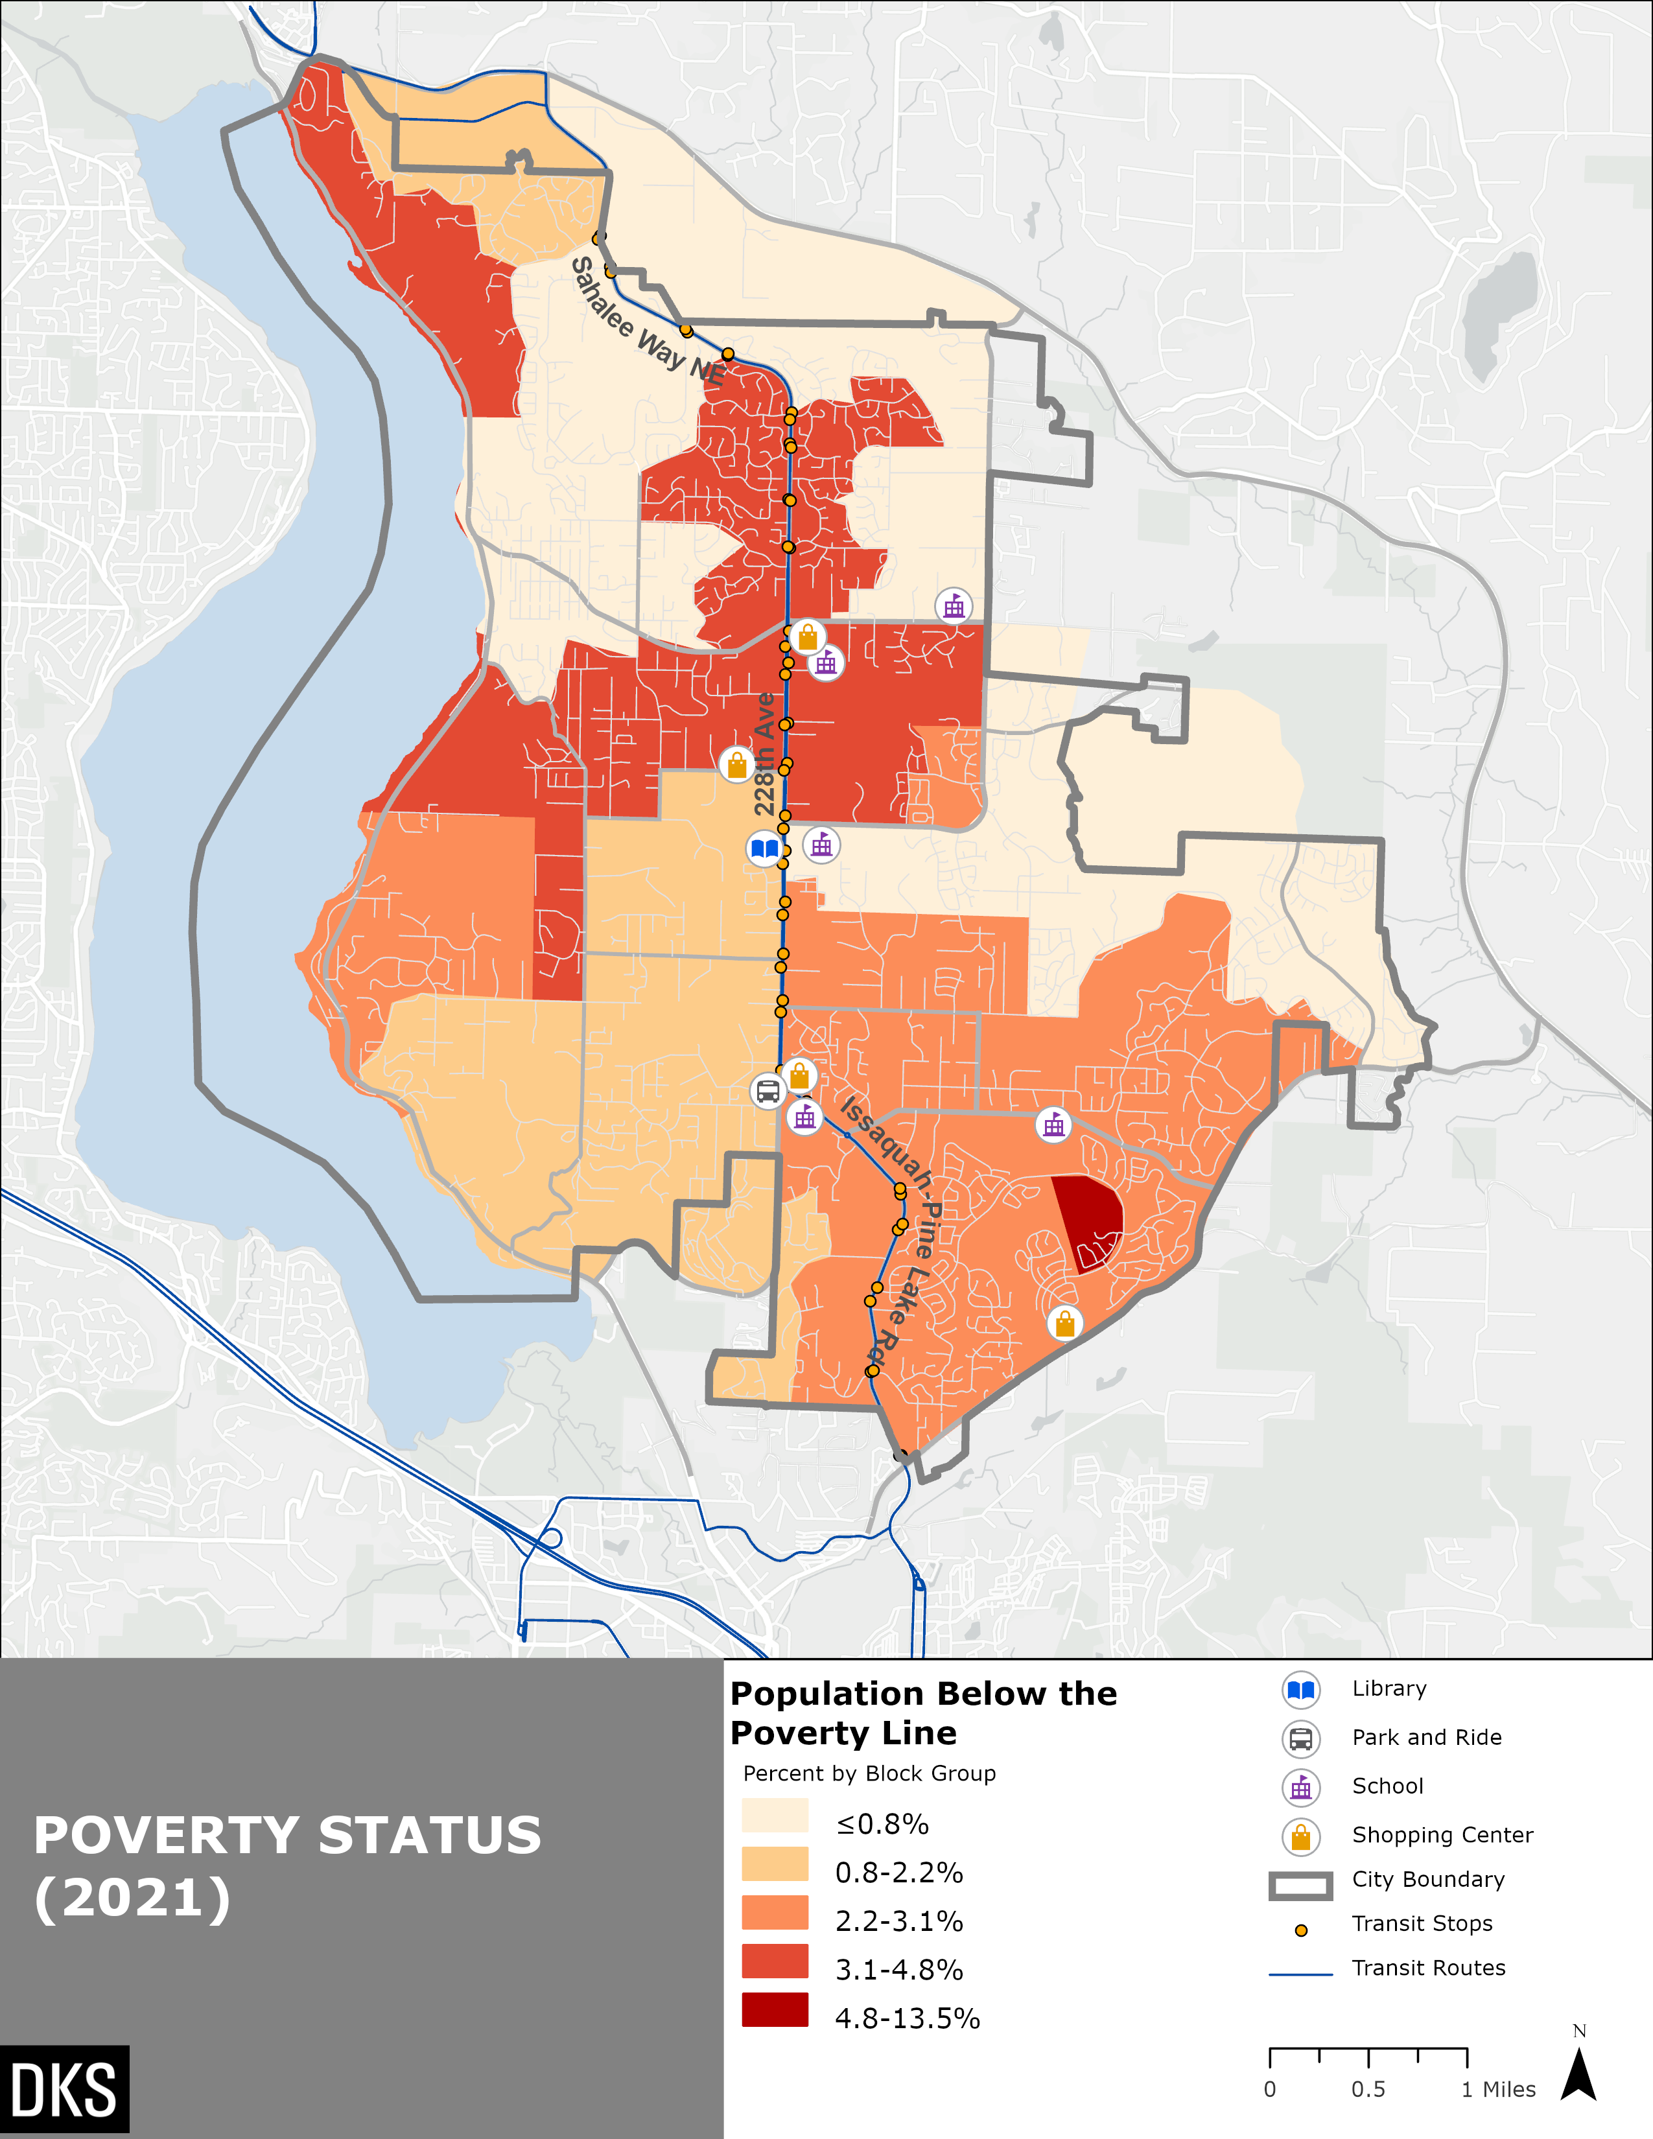
Figure 4: GEOGRAPHIC DISTRIBUTION OF LOW-INCOME POPULATION BY BLOCK GROUP
Source: US Census 2021
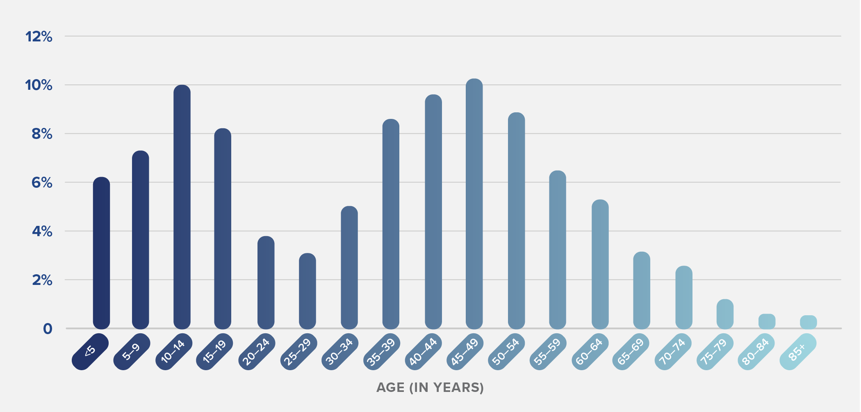
Figure 5: aGE BREAKDOWN OF Sammamish pOPULATION
Source: US Census 2021

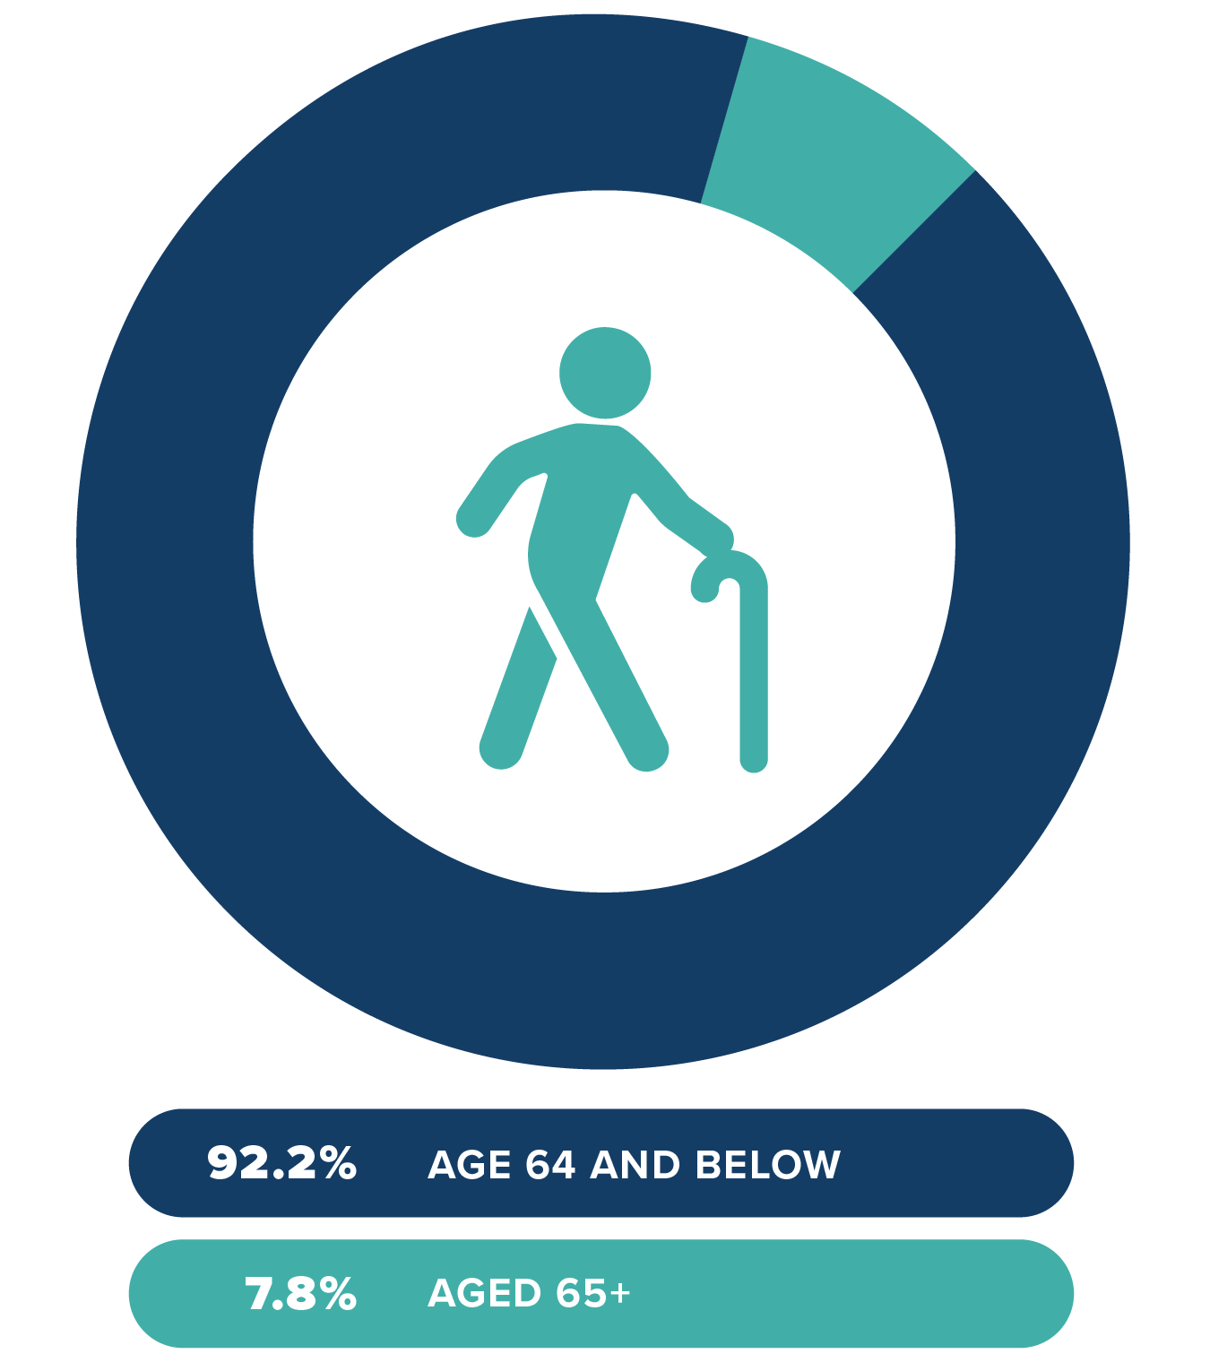
Figure 6: sENIORS 65+ lIVING IN Sammamish
Source: US Census 2021
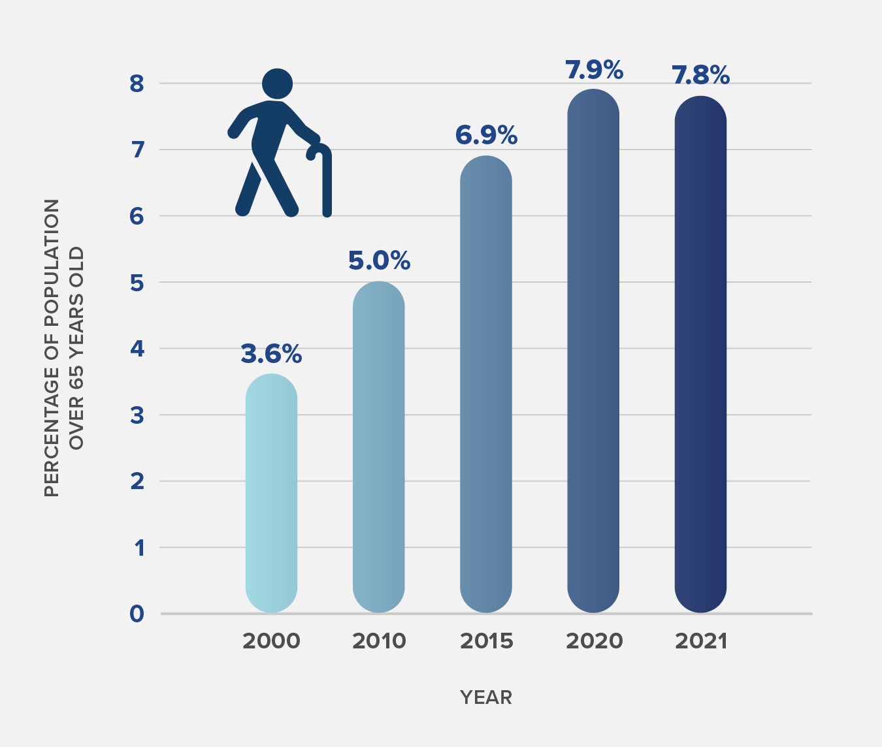
Figure 7: Senior 65+ Sammamish Population over time
Source: US Census 2021

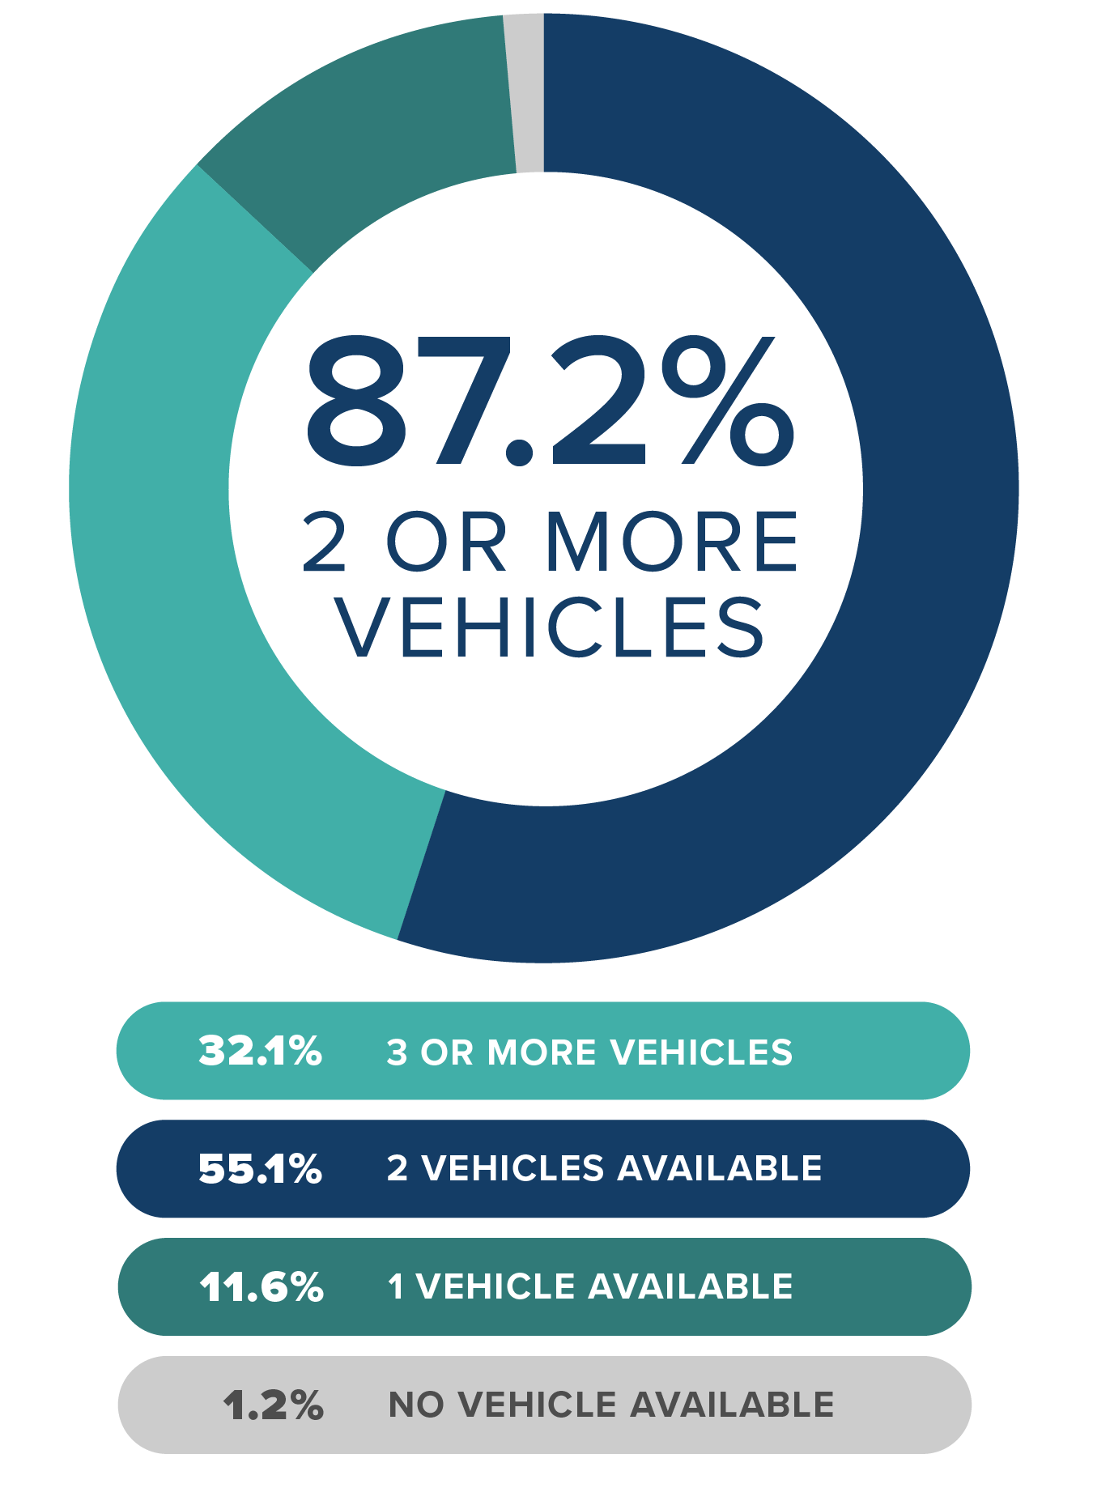
Figure 8: aVAILABLE vEHICLES PER Occupied hOUSING uNIT in Sammamish
Source: US Census 2021
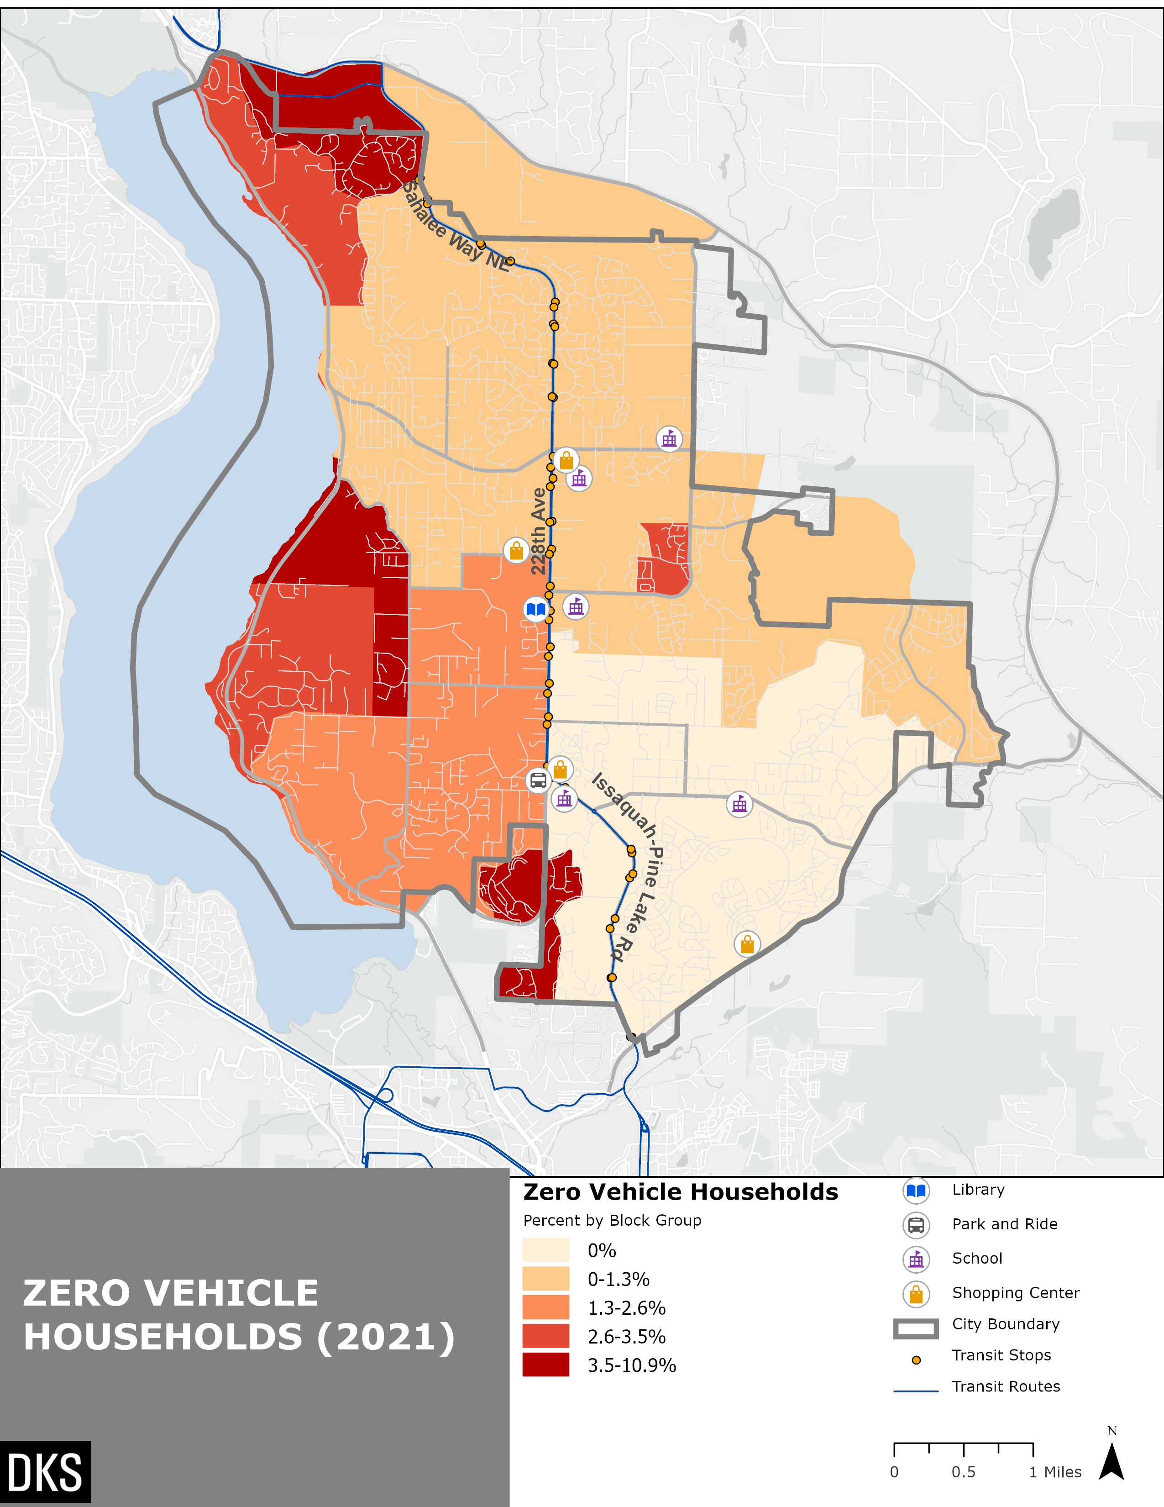
Figure 9: gEOGRAPHIC dISTRIBUTION OF Zero Vehicle hOUSEHOLDS BY bLOCK gROUP
Source: US Census 2021
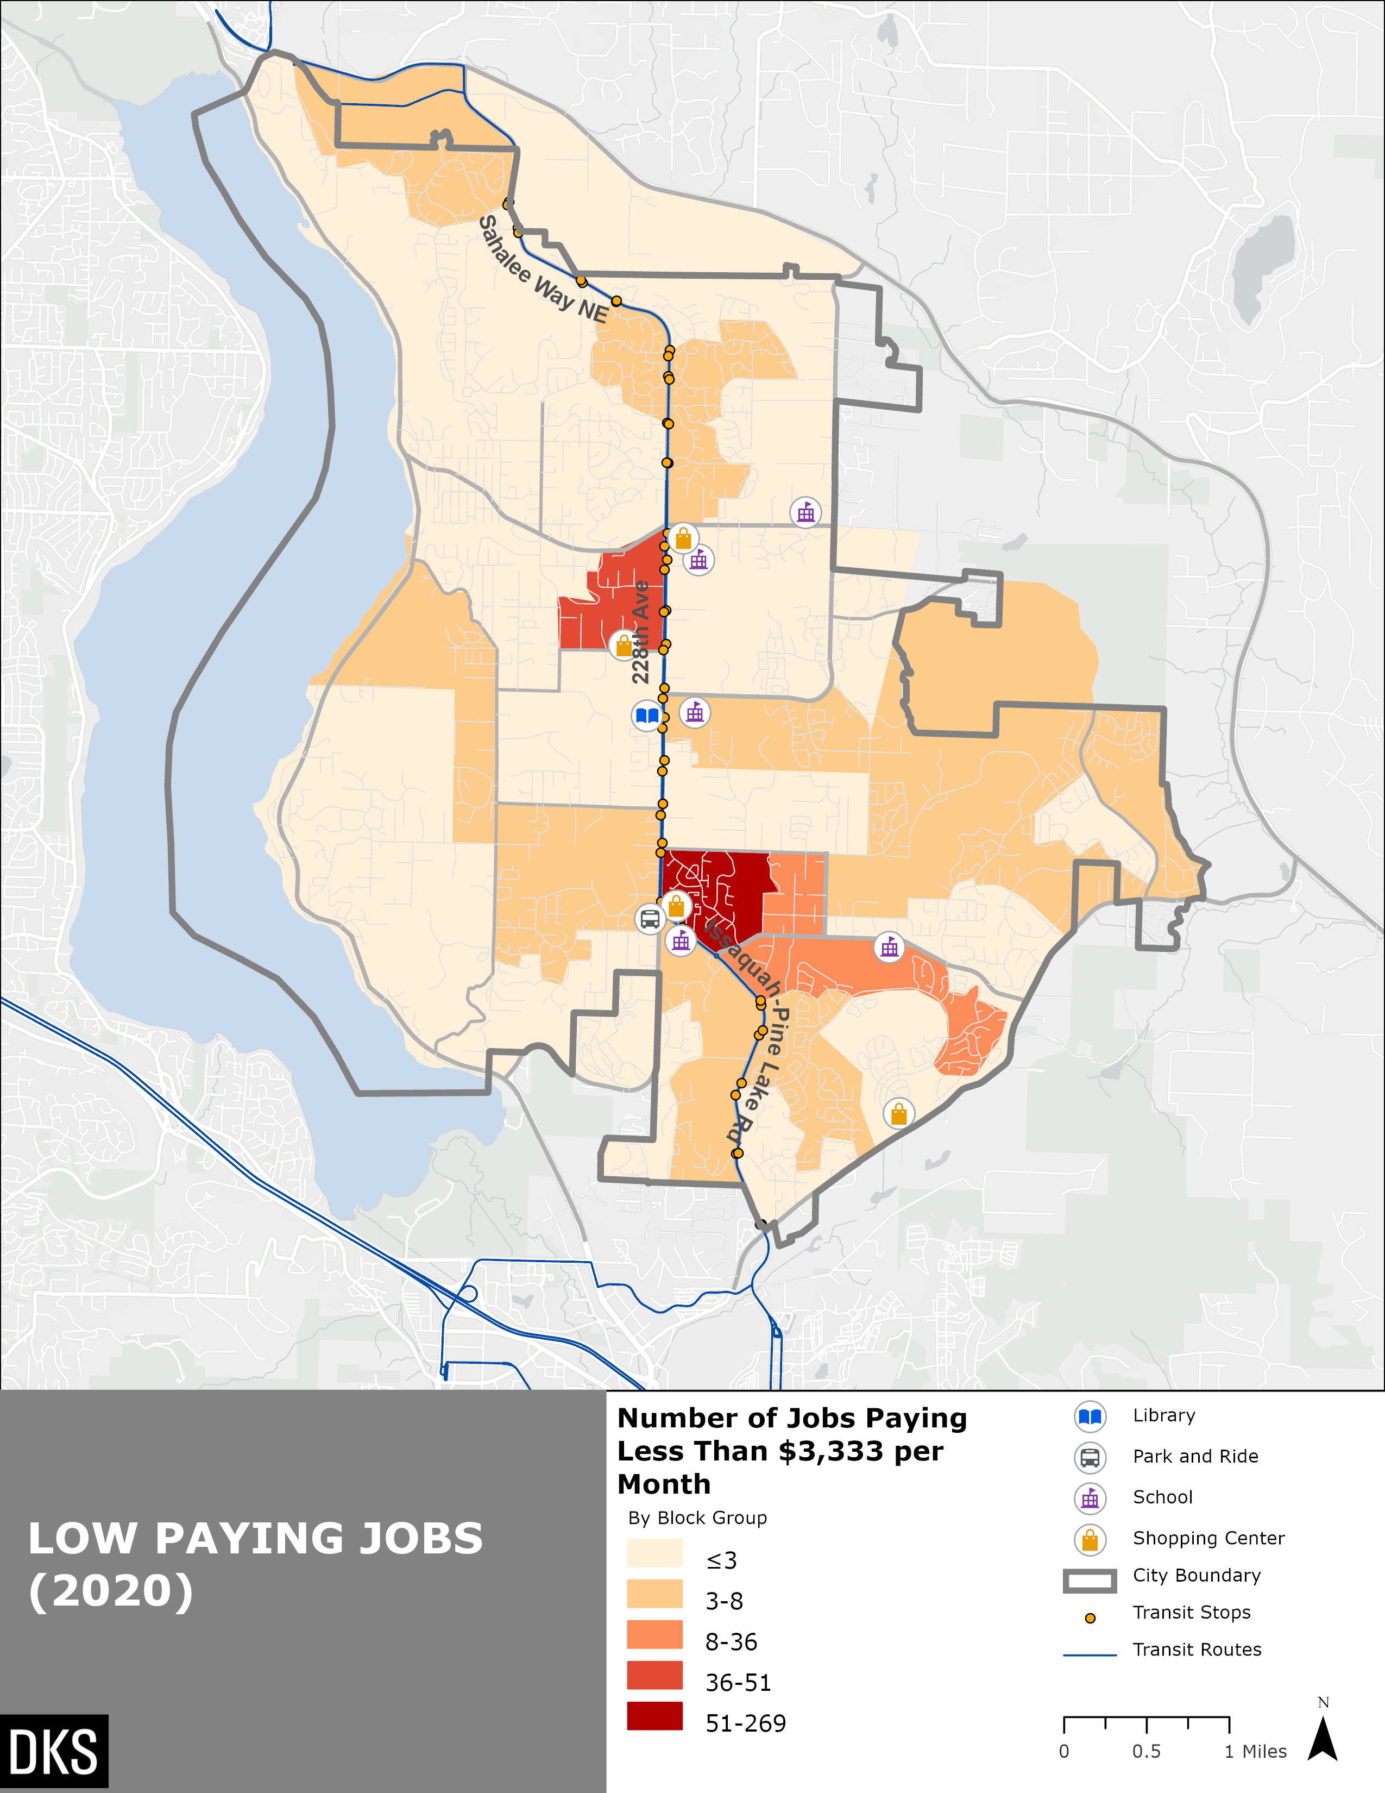
Figure 10: Geographic distribution of jobs by block group
Source: US Census 2020

Existing Commute Patterns

Key Takeaways- Existing Commute Patterns
US Census and ACS data was used to analyze transportation-related characteristics of those living in Sammamish. As shown in Figure 11, for commute trips, the majority of people drive alone at 60%. The next highest commute mode choice is work from home at 24.6%. These workers do not use transportation services for regular commuting. Figure 11 also shows the commute mode share excluding people who work from home. It is notable that the drive alone proportion increases to 79.6% once non-commuters are removed. Figure 12 shows the average commute time for workers living in Sammamish by commute mode. Of all those commuting to work, 12.4% of workers have a commute longer than an hour. This number increases significantly to 64% for public transit commuters. The data shows that no public transit commuters in Sammamish have computers less than 35 minutes. Generally, those who carpool are more likely to have a longer commute than those who drive alone.
Figure 13 shows that walking, biking, and transit comprise 9% of Sammamish commute trips when excluding those who work from home. Transit commute trips are most numerous in Census blocks groups surrounding the intersection of 228th Avenue and NE 8th Street, as illustrated in Figure 14. This area of Sammamish is directly adjacent to the Sammamish Highlands shopping center on the east side of 228th Avenue as well as a condominium development on the west side of 228th Avenue. Other pockets of relatively high public transit usage for commuting includes the Klahanie neighborhood and a block group at the southwest area of town despite these locations not having adjacent access to transit stops.
At the Census block group level, the highest levels of commuting by transit (Figure 14) have the strongest correlation with low-paying jobs. The highest levels of commuting by transit also correlated with being close to a transit stop. Commuting by transit was not especially related to other demographic characteristics including population density, racial/ethnic minorities, people with low incomes, and zero vehicle households.

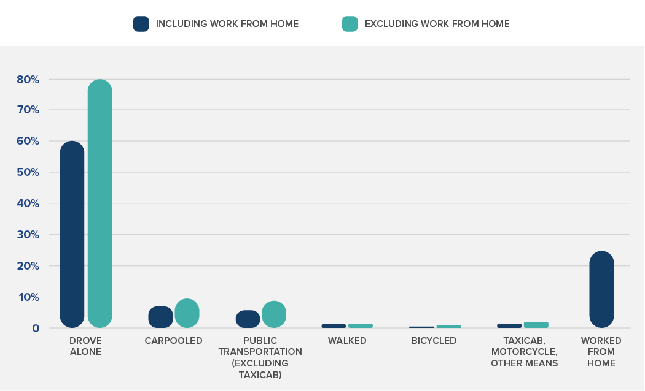
Figure 11: Commute mode share within Sammamish (Including and Excluding work from Home)
Source: US Census 2021

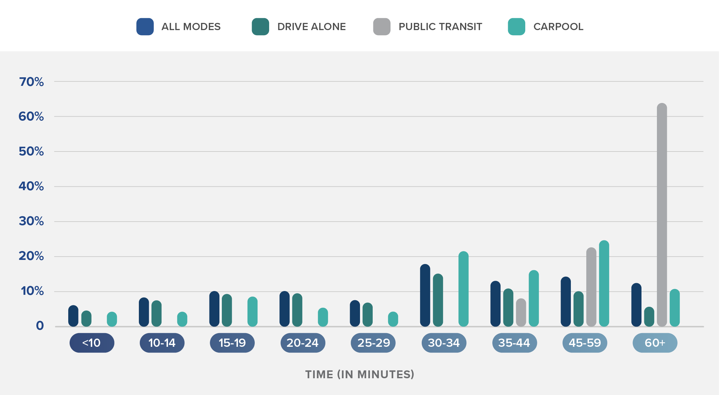
Figure 12: Commute Travel Time by Mode for Workers Living in Sammamish

Figure 13: Commuters Walking, Biking, or Using Pulblic Transit in Sammamish (excluding WOrk from Home)
Source: US Census 2021

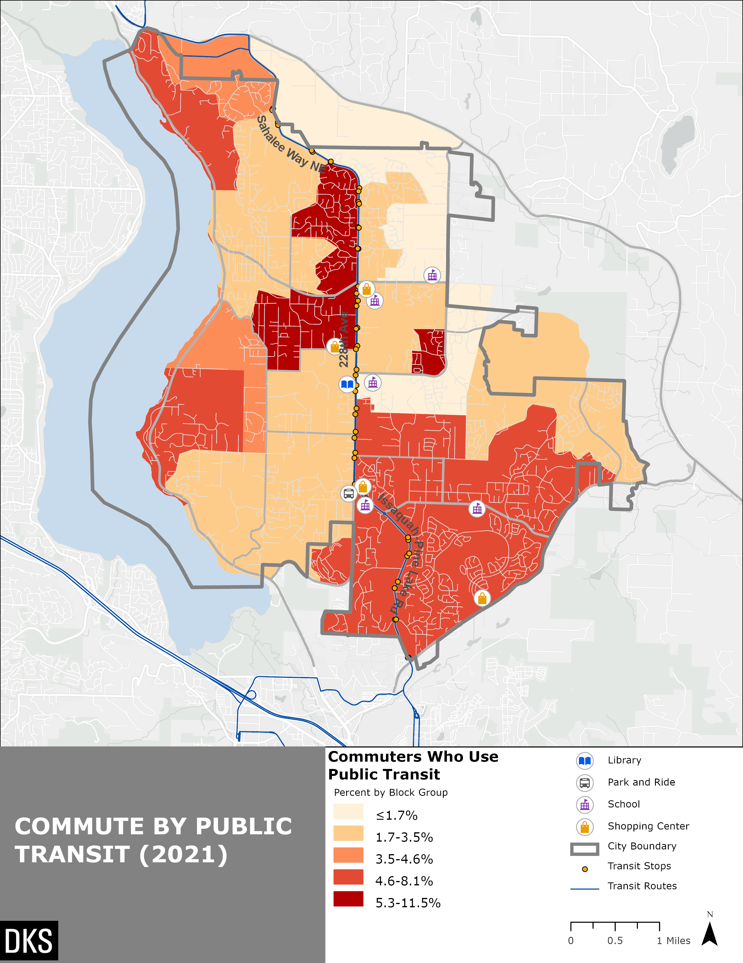
Figure 14: Geographic Distribution of Commuters taking Public Transit by Block Group
Source: US Census 2021

Vanpools and other Alternatives
King County Metro runs a vanpool service for commuters. This service is similar to a carpool, with King County Metro providing the van and a website to connect with other commuters. The service allows commuters to join an existing vanpool or create their own with a minimum of three members. Each commuter pays a fare which includes the van, gas, insurance, maintenance, roadside assistance, and a guaranteed ride home.
There are over 70 different vanpool routes with an origin in Sammamish. Many of these vanpools travel to downtown Seattle to employers such as Amazon, Expedia, F5, and Starbucks. Other destinations include T-Mobile in Bellevue and Microsoft in Redmond. No vanpools currently have Sammamish as a destination.
Other non-fixed route service options include Metro Flex, formerly known in Sammamish as Community Ride. Metro Flex is a service provided by King County Metro through a contractor, Via, that provides on-demand neighborhood transit service in a limited area. More information on Metro Flex is provided later in this report.
King County Metro also runs Access Transportation, which provides direct door-to-door service for those who qualify for the Americans with Disability Act (ADA) Paratransit Program. Within the City of Sammamish, there were 939 trips taken by 27 unique riders between January 1, 2022 and July 10, 2023. This equates to about 50 trips per month within Sammamish.

Existing Transit Network
As of Fall 2022, Sammamish is served by three bus routes that provide connections within east King County and to Seattle. One metro bus line, Route 219 was previously suspended in 2020 due to impacts from COVID-19. Another metro bus line, Route 216 will be suspended indefinitely in Fall 2023. Below is a summary of metro bus lines including recently suspended routes:
- One all-day route (269) that operates every 30 minutes or more often. This route provides connection from Issaquah to the Redmond area, with several stops in Sammamish.
- One peak-only, peak-direction route (216) that connects to downtown Seattle and to the Bear Creek Park & Ride in Redmond. This route is currently planned to be indefinitely suspended by King County Metro starting with the Fall 2023 Service Revision.
- One previously suspended peak-only, peak-direction route (219) that was in operation until Spring 2020 and suspended due to impacts from the COIVID-19 pandemic. Prior to being suspended, the route ran from Redmond to Seattle.
- One limited-service route (554) that is operated by Sound Transit. Route 554 is an express route with all-day 30-minute or better service between Seattle and Issaquah. The route extends from Issaquah, through Sammamish, and to Redmond for five trips in the northbound direction during the evening and late night and two trips in the southbound direction during the early morning.
Figure 15 illustrates current transit service in Sammamish.
Table 1 summarizes service characteristics of each route on weekdays as of Fall 2022. The table highlights service changes since Fall 2019 in which King County Metro suspended Route 219 due to low ridership during the pandemic.
In Fall 2016, there were 66 weekday transit trips serving Sammamish. In Fall 2019, prior to the COVID-19 pandemic, there were 91 daily weekday transit trips serving Sammamish. In Fall 2022, there were 64 daily weekday transit trips, following service reductions due to the pandemic.

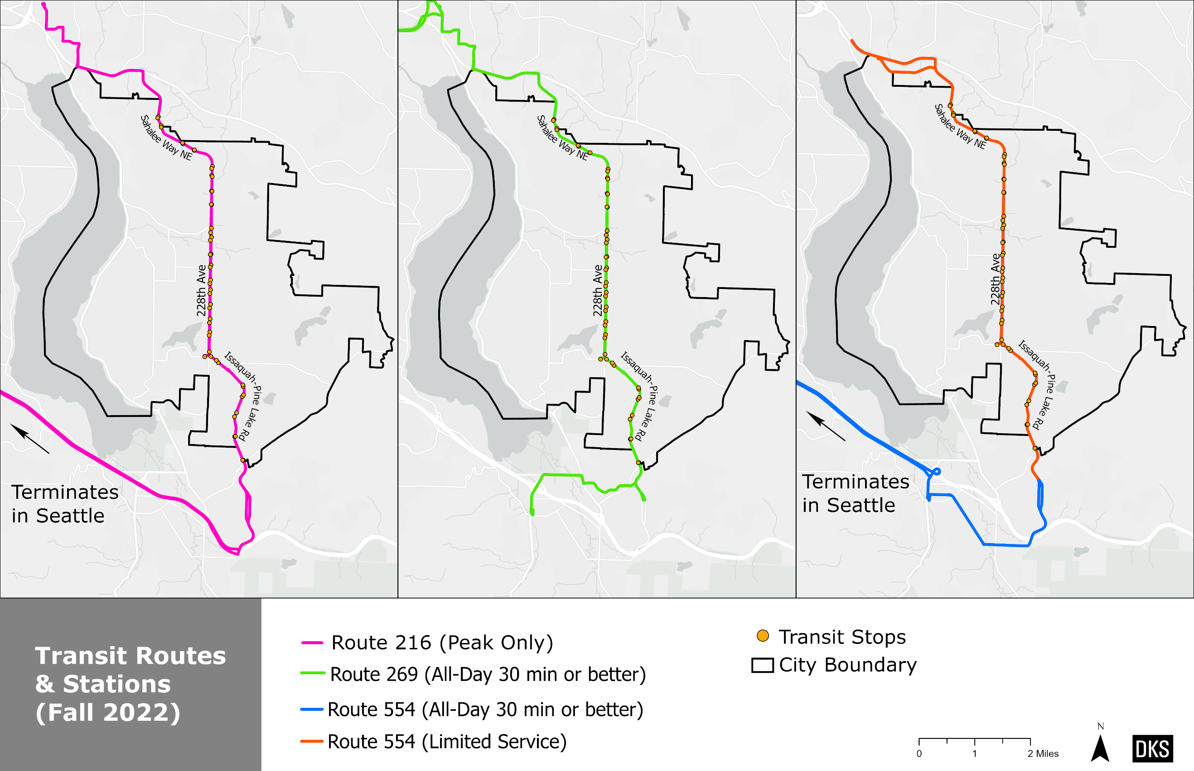
Figure 15: Bus routes By type and station locations, Fall 2022
Table 1 Weekday Transit Routes Overview, fall 2016, 2019 and 2022
Route | Route Description | Service Type (Sammamish) | Weekday Service Span (Sammamish) | Weekday Headway |  |  |  | # of Weekday Daily Trips |  |  | Notes
 |  |  |  | AM Peak | Mid-day | PM Peak | Eve | Fall 2016 | Fall 2019 | Fall 2022
216 | Bear Creek / Issaquah Highlands / Eastgate / Downtown Seattle | Peak-Only | 6:54 AM to 6:10 PM | 45 | - | 30 | - | 13 | 14 | 7 | [1]
219 | Redmond / Issaquah Highlands / Downtown Seattle | Peak-Only | 6:26 AM to 6:54 PM  (Fall 2019) | 30 | - | 30 | - | 15 | 15 | - | [2]
269 | Issaquah TC / North Issaquah / Issaquah Highlands / Bear Creek / Overlake | All-Day (30 min or better) | 6:23 AM to 7:39PM | 30 | 30 | 30 | 45 | 31 | 55 | 50
554 | Redmond / Issaquah Highlands / Issaquah TC/ Downtown Seattle | Peak-Only | 4:38 AM to 11:41 PM | - | - | - | 120 | 7 | 7 | 7 | [3]
Notes: Rows in gray represent routes which have been suspended since Spring 2020. Service span was based on the first and last stops within Sammamish. Headway was based on trips serving Sammamish and was generally categorized using the following ranges: 30=16-30 min, 45=31-45 min, 120=61-120 min. These ranges were adjusted, simplified, or reported as a range or average to reflect the irregular frequency of some routes that serve Sammamish. [1] Service in peak direction only. [2] Route 219 was indefinitely suspended during the COVID-19 pandemic. [3] Route 554 only serves stops in Sammamish for select trips throughout the day: 5 trips northbound in the evening/late night and 2 trips southbound in the early morning.
Weekend Service
While weekday transit service typically provides for the needs of typical peak-period commuters, weekend service is also an
important resource for carrying out the tasks of everyday life. A robust transit network provides weekend service which allows
its riders to reach a variety of destinations, facilitates a car-free or “car-light” lifestyle, and aligns well with transit-oriented
development (TOD) land-use strategies. As of Fall 2022, there is no fixed route service in Sammamish on either weekend day. Route 554 does run on the weekend; however, the end of the route is at the Issaquah Highlands Park & Ride and does not continue through Sammamish to Redmond.

Short-Term Transit Network Changes (2025)
King County Metro is finalizing their recommended service network for the East Link Connections project prior to the opening of the Link 2 Line. This project, which is expected to be completed in 2025, includes re-routing many of the existing transit routes in King County as well as the addition of several new routes and the elimination of several others. Table 2 describes the anticipated changes to service in Sammamish in 2025.
Table 2 Anticipated 2025 Service Changes in Sammamish
Route | Route Description | Proposed Changes in East Link Connection Project
216 | Bear Creek / Issaquah Highlands / Eastgate / Downtown Seattle | To be eliminated in Fall 2023. In 2025, it will be replaced by revised Routes 218 and 269 along the same alignment within Sammamish.
269 | Issaquah TC / North Issaquah / Issaquah Highlands / Bear Creek / Overlake | Re-routes service along I-90 to terminate at Mercer Island Link Station. No alignment changes in Sammamish.  More frequent service, with 15-minute headways during the weekday peak, and 30-minute headways during the rest of the weekday. Added weekend service with 30-minute headways from 5am to 7pm.
554 | Redmond / Issaquah Highlands / Issaquah TC/ Downtown Seattle | No alignment changes within Sammamish; will truncate in Bellevue at the South Bellevue Station when the full Link 2 Line opens. This route continues to have limited service through Sammamish.

Ridership
Figure 16 illustrates boarding and alightings in Sammamish for Fall 2022, which are concentrated at Sammamish Highlands Shopping Center (228th Avenue NE between NE 4th Street and NE 8th Street) and at South Sammamish Park & Ride. These locations include or are adjacent to retail, employment, and medical destinations.

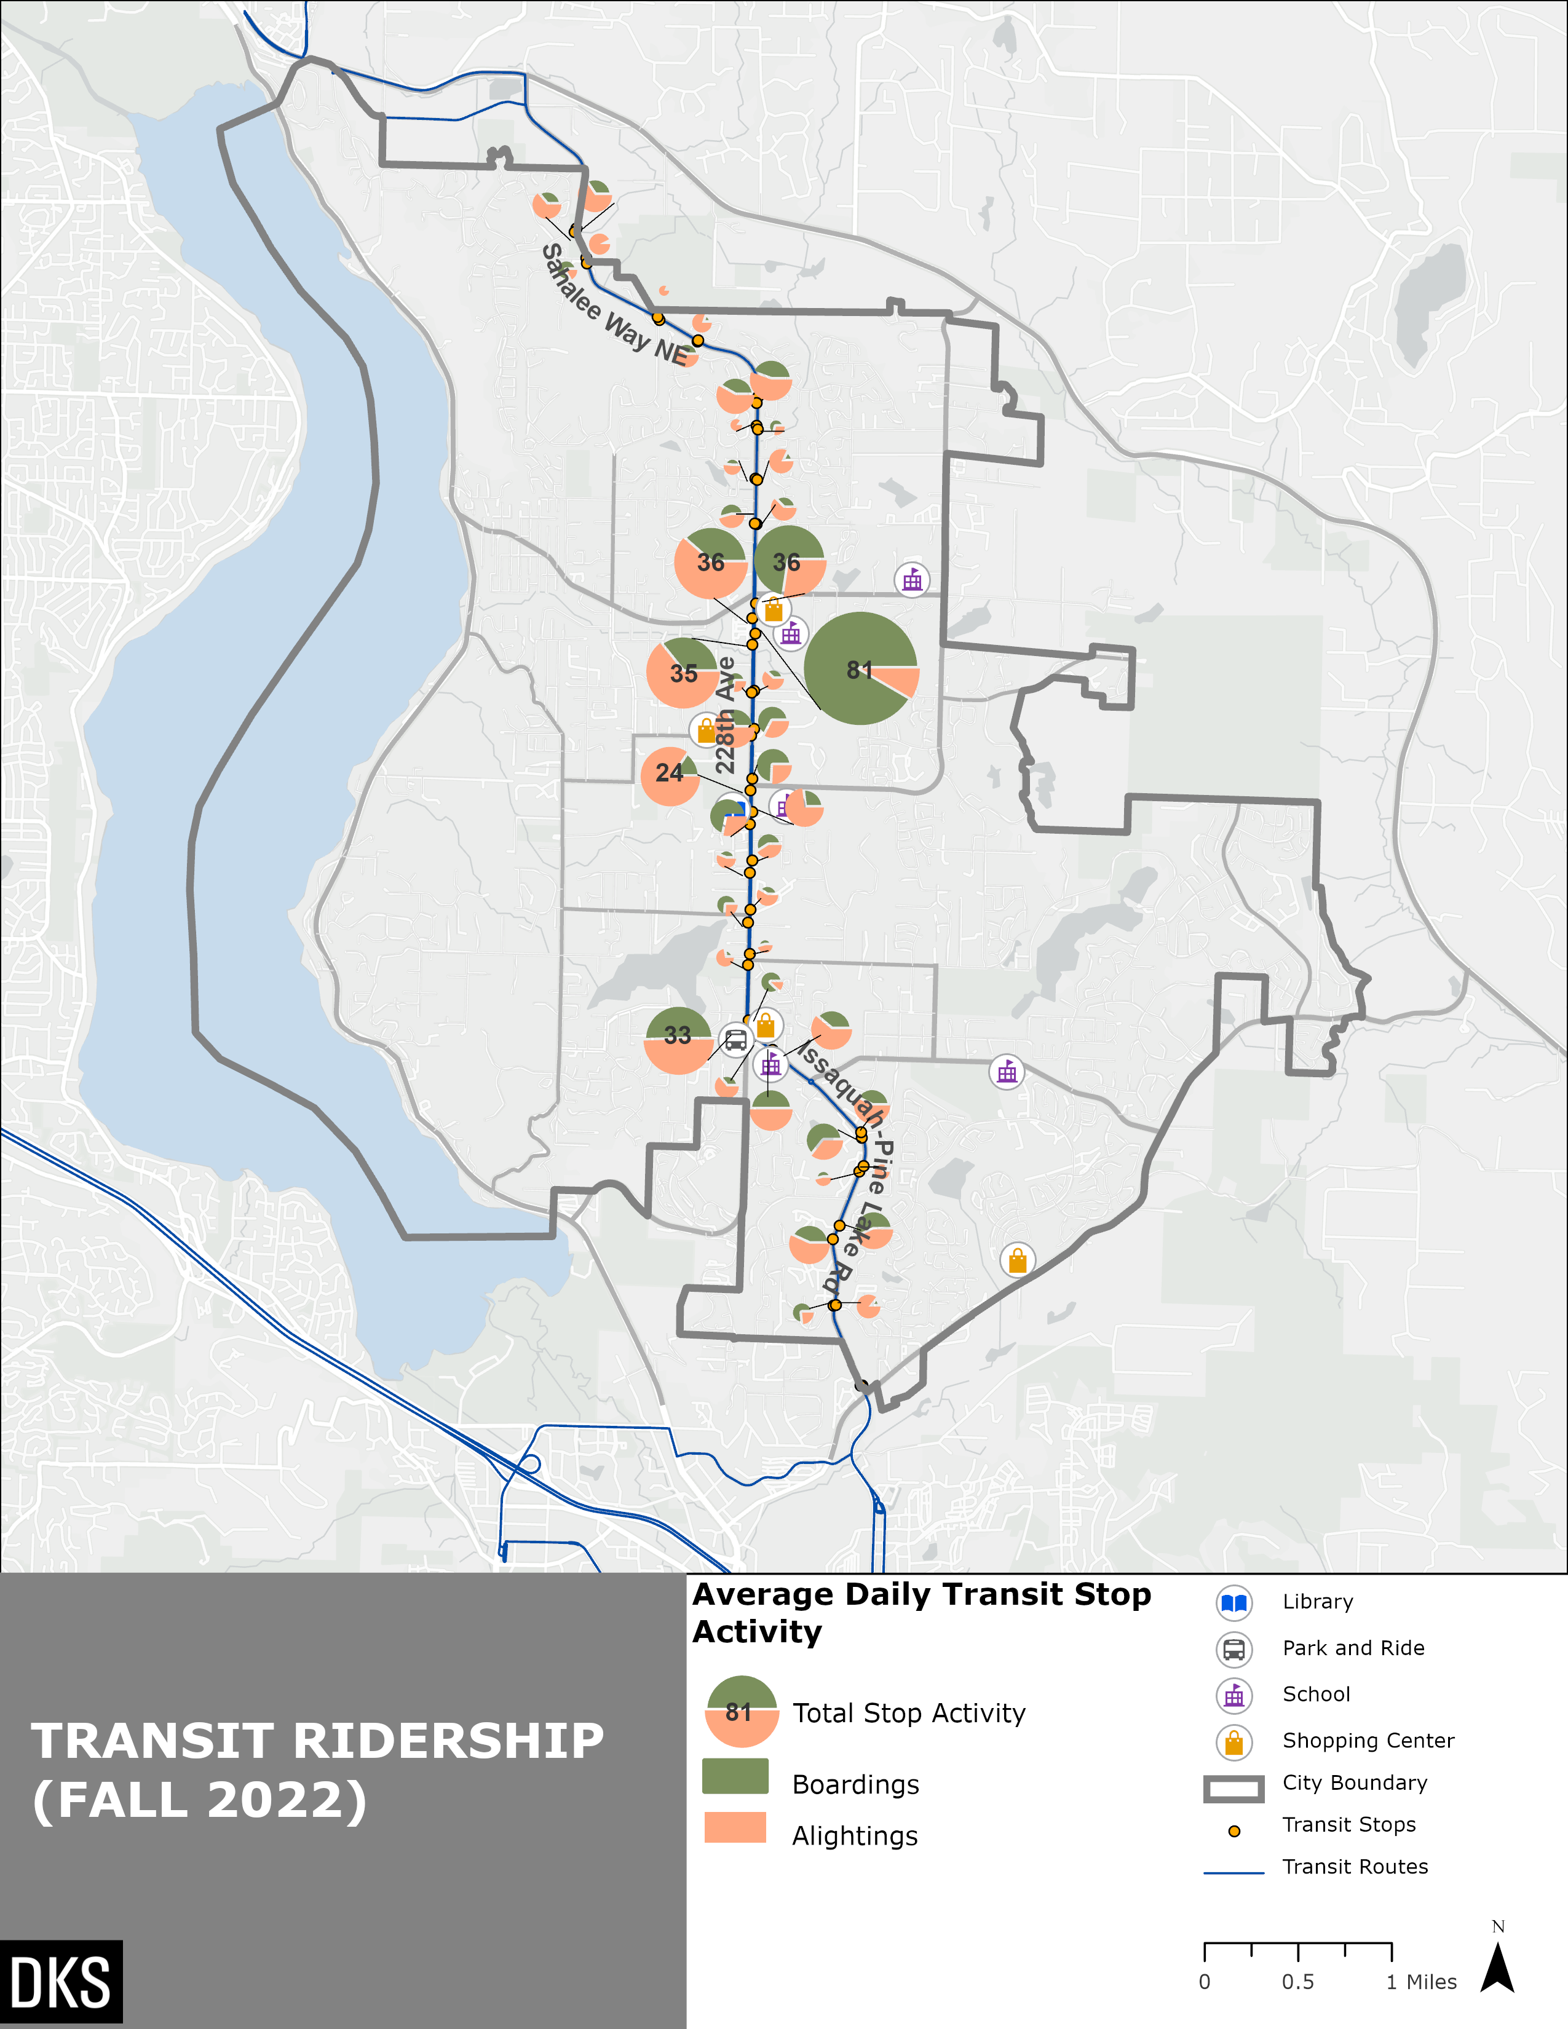
Figure 16: Transit Ridership within Sammamish
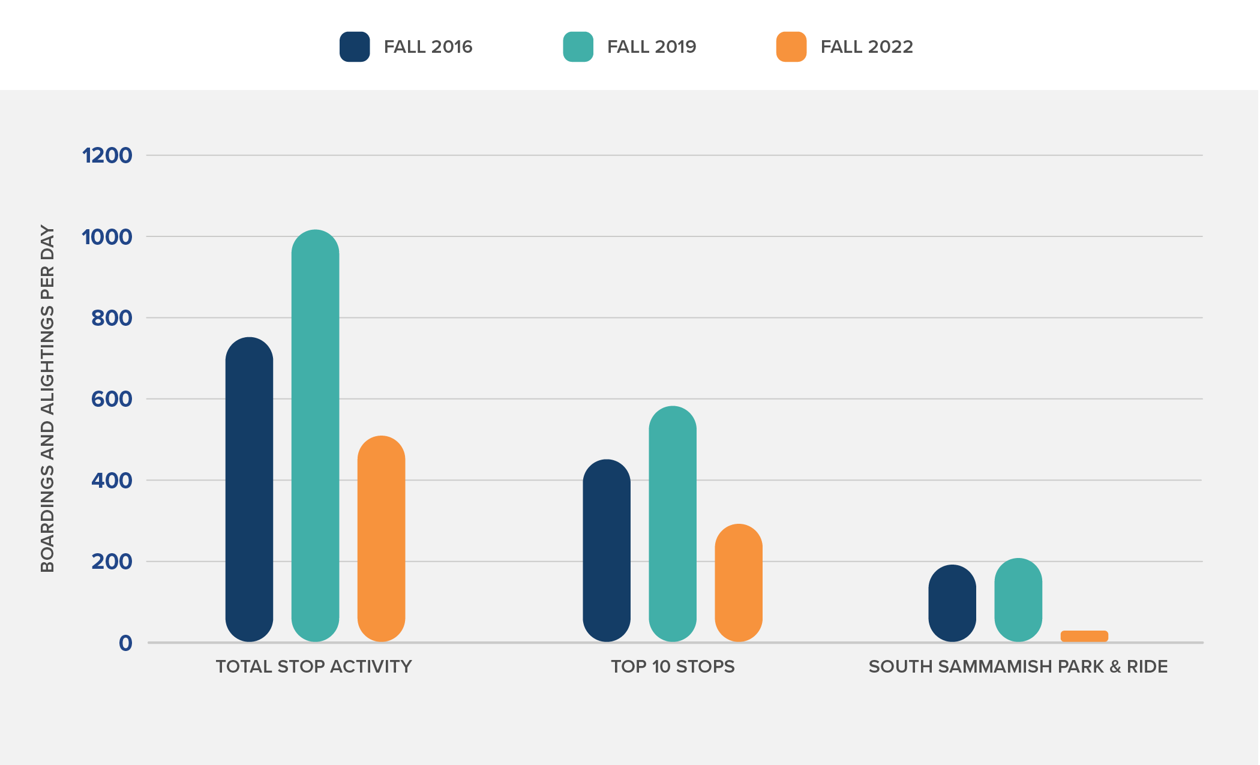
Figure 17: Transit Ridership by Year
Figure 17 compares transit ridership between Fall of 2016, 2019, and 2022 within Sammamish. Transit ridership increased between 2016 and 2019, which represents the peak. Total stop activity (boardings + alightings) decreased 35% between 2019 and 2022. The South Sammamish Park and Ride was the highest stop activity in Sammamish stop in 2016 and 2019 with a total daily activity level of 192 and 212, respectively. In 2022, the total activity level at the Park and Ride dropped to 33 and was the stop with the fifth highest stop activity. This decrease may be indicative of post-COVID work from home patterns in which there is less demand to use transit to travel between Sammamish and regional employment centers.

Metro Flex
Metro Flex is a service provided by King County Metro through a contractor, Via, that provides on-demand neighborhood transit service for the same cost as a bus trip. This service is provided for trips beginning and ending in a certain area of Sammamish between 7am and 6pm Monday through Friday and between 9am and 6pm on Saturdays. Figure 18 shows the Metro Flex service area for Sammamish. In April 2023, Metro Flex in Sammamish had an average of 78 daily rides.
Metro Flex was introduced in March 2023. Prior to this, King County Metro ran a similar service known in Sammamish as Community Ride for about three years. Metro Flex uses a van, whereas Community Ride used a shuttle, and Metro Flex may require users to walk a short distance, whereas Community Ride was a door-to-door service.
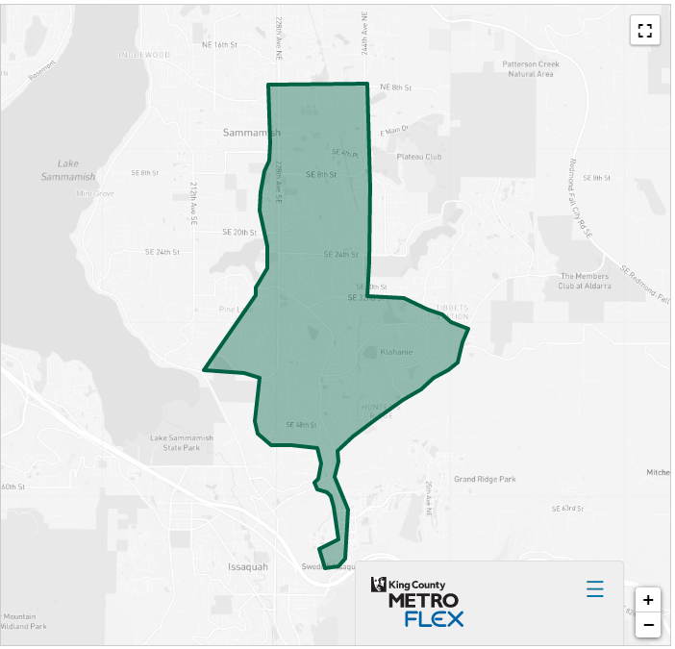
Figure 18: Metro Flex Service area in Sammamish

Key Takeaways– Existing Transit Network
The fixed route bus transit service in Sammamish provides service along 228th Ave SE and Issaquah-Pine Lake Road. This is a major arterial in the City. There is no fixed-route transit service in the neighborhoods or on other arterials. Three bus routes serve Sammamish on weekdays only. Of these routes, only Route 269 provides all-day service. This route connects Sammamish with Redmond and Issaquah, where riders can transfer to other transit routes. Direct service to other key destinations such as Seattle is only provided during the peak hour. There are 64 weekday transit trips that serve Sammamish as of Fall 2022, which is 27 fewer than in Fall 2019. Metro Flex fills a gap by providing on-demand service to an area of Sammamish that includes Pine Lake Village, Sammamish Highlands, and Sammamish Town Center commercial areas as well as the South Sammamish Park and Ride.

Existing Access to Transit
A rule-of-thumb is that people are willing to walk approximately 5 to 10 minutes to a transit stop, which generally equates to a ¼ to ½ mile walk. These thresholds were determined through empirical research presented in the Transit Capacity and Quality of Service Manual, 3rd Edition. On average, 75% to 80% of people walk ¼ mile or less to a transit stop. One factor that is a significant determinant in the distance one is willing to walk to a transit stop is the grade of the pedestrian environment. Research shows that once grades exceed 5%, the distance one is able to walk in 5 to 10 minutes diminishes. Sammamish is a hilly city with significant grades and elevation changes both along the bus routes and in the residential areas. These grades were not analyzed for impact on walking and biking distances. For reference, a contour map is provided as Figure 20.
Both ½ mile and ¼ mile walking distances are analyzed in this report. Table 3 summarizes demographics within ¼ and ½ mile access of bus stops in Sammamish. Approximately 6% of Sammamish’s population lives within ¼ mile walking distance of a bus stop, and approximately 14% live within a ½ mile walking distance (see Table 3 and Figure 19). Transit access within ¼ and ½ mile of a bus stop for people of color, low-income people, and people who do not own a vehicle is similar to the overall population.
Bicycle access to transit peaks at 1 to 1.25 miles which approximately equals a 5-minute bike ride¹. However, this distance can increase or decrease based on environmental factors such as weather and grade. As mentioned above, grade and hills play a role in a users decision to walk or bike, as well as the distance one is able walk or bike in 5 to 10 minutes. For the purposes of this report, a 1-mile bike trip distance is used as a conservative estimate of bicycle catchment area. About 35% of the City is within a 1-mile biking distance of a transit stop (see Figure 21).
Park and Ride facilities should be located within a 2.5-mile radius of population centers to best maximize facility usage. About 37% of the City is within a 2.5-mile driving distance of South Sammamish Park and Ride (see Figure 22).
A relatively small share of the city’s jobs is within walking distance of a bus stop—11% within ¼ mile and 26% within ½ mile. The share of low to moderate wage jobs within either ¼ mile-radius and ½ mile-radius of a bus stop is slightly higher at 14% and 33%, respectively.

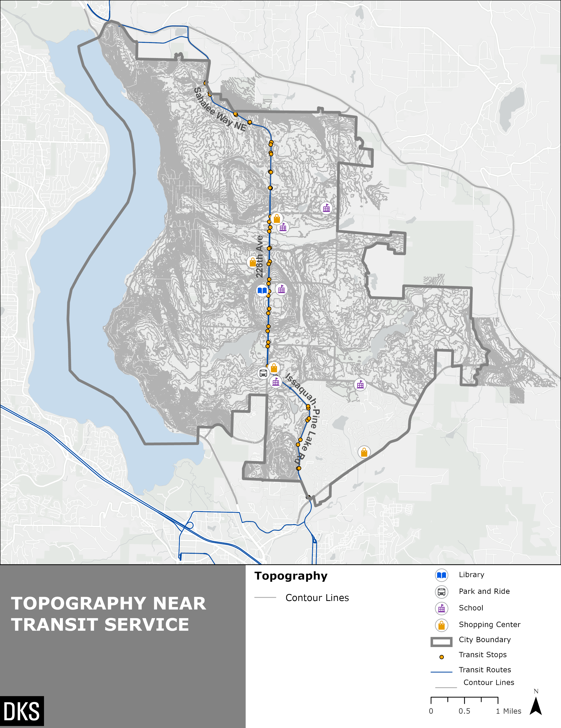
Figure 19: Topographical Features Near Transit Service in Sammamish
Note: Topography data is missing for the Klahanie neighborhood
Table 3 Walkshed Demographicsand Jobs Data (2020)
 |  | Access to Transit
Area [1] |  | Total Population (2020) | Persons of Color (2020) | Low-Income Population [2] (2020) | Zero Car Households (2020) | Total Jobs (2020) | Low/Mod Income Jobs (2020) [3]
Total City |  | 67,455 | 30,690 | 2,047 | 575 | 1,209 | 485
¼-Mile Walkshed | # | 4,110 | 1,750 | 155 | 35 | 136 | 67
 | % | 6.1% | 5.7% | 7.6% | 6.1% | 11.2% | 13.8%
½-Mile Walkshed | # | 9,675 | 4,940 | 360 | 82 | 316 | 160
 | % | 14.3% | 16.1% | 17.6% | 14.2% | 26.1% | 33.0%
Notes: [1] Demographics and jobs with ¼ or ½ mile access transit were calculated with an area-weighted sum of walksheds and Census block groups. [2] Low-Income population is based on the federal poverty line. [3] Low/moderate income jobs are based on monthly pay of up to $3,333. [3]
Source: Population and demographics are from the American Community Survey, 2016-2020 Five-Year Estimates. Jobs are from the US Census Longitudinal Household Employer Dynamics (LEHD), 2020.

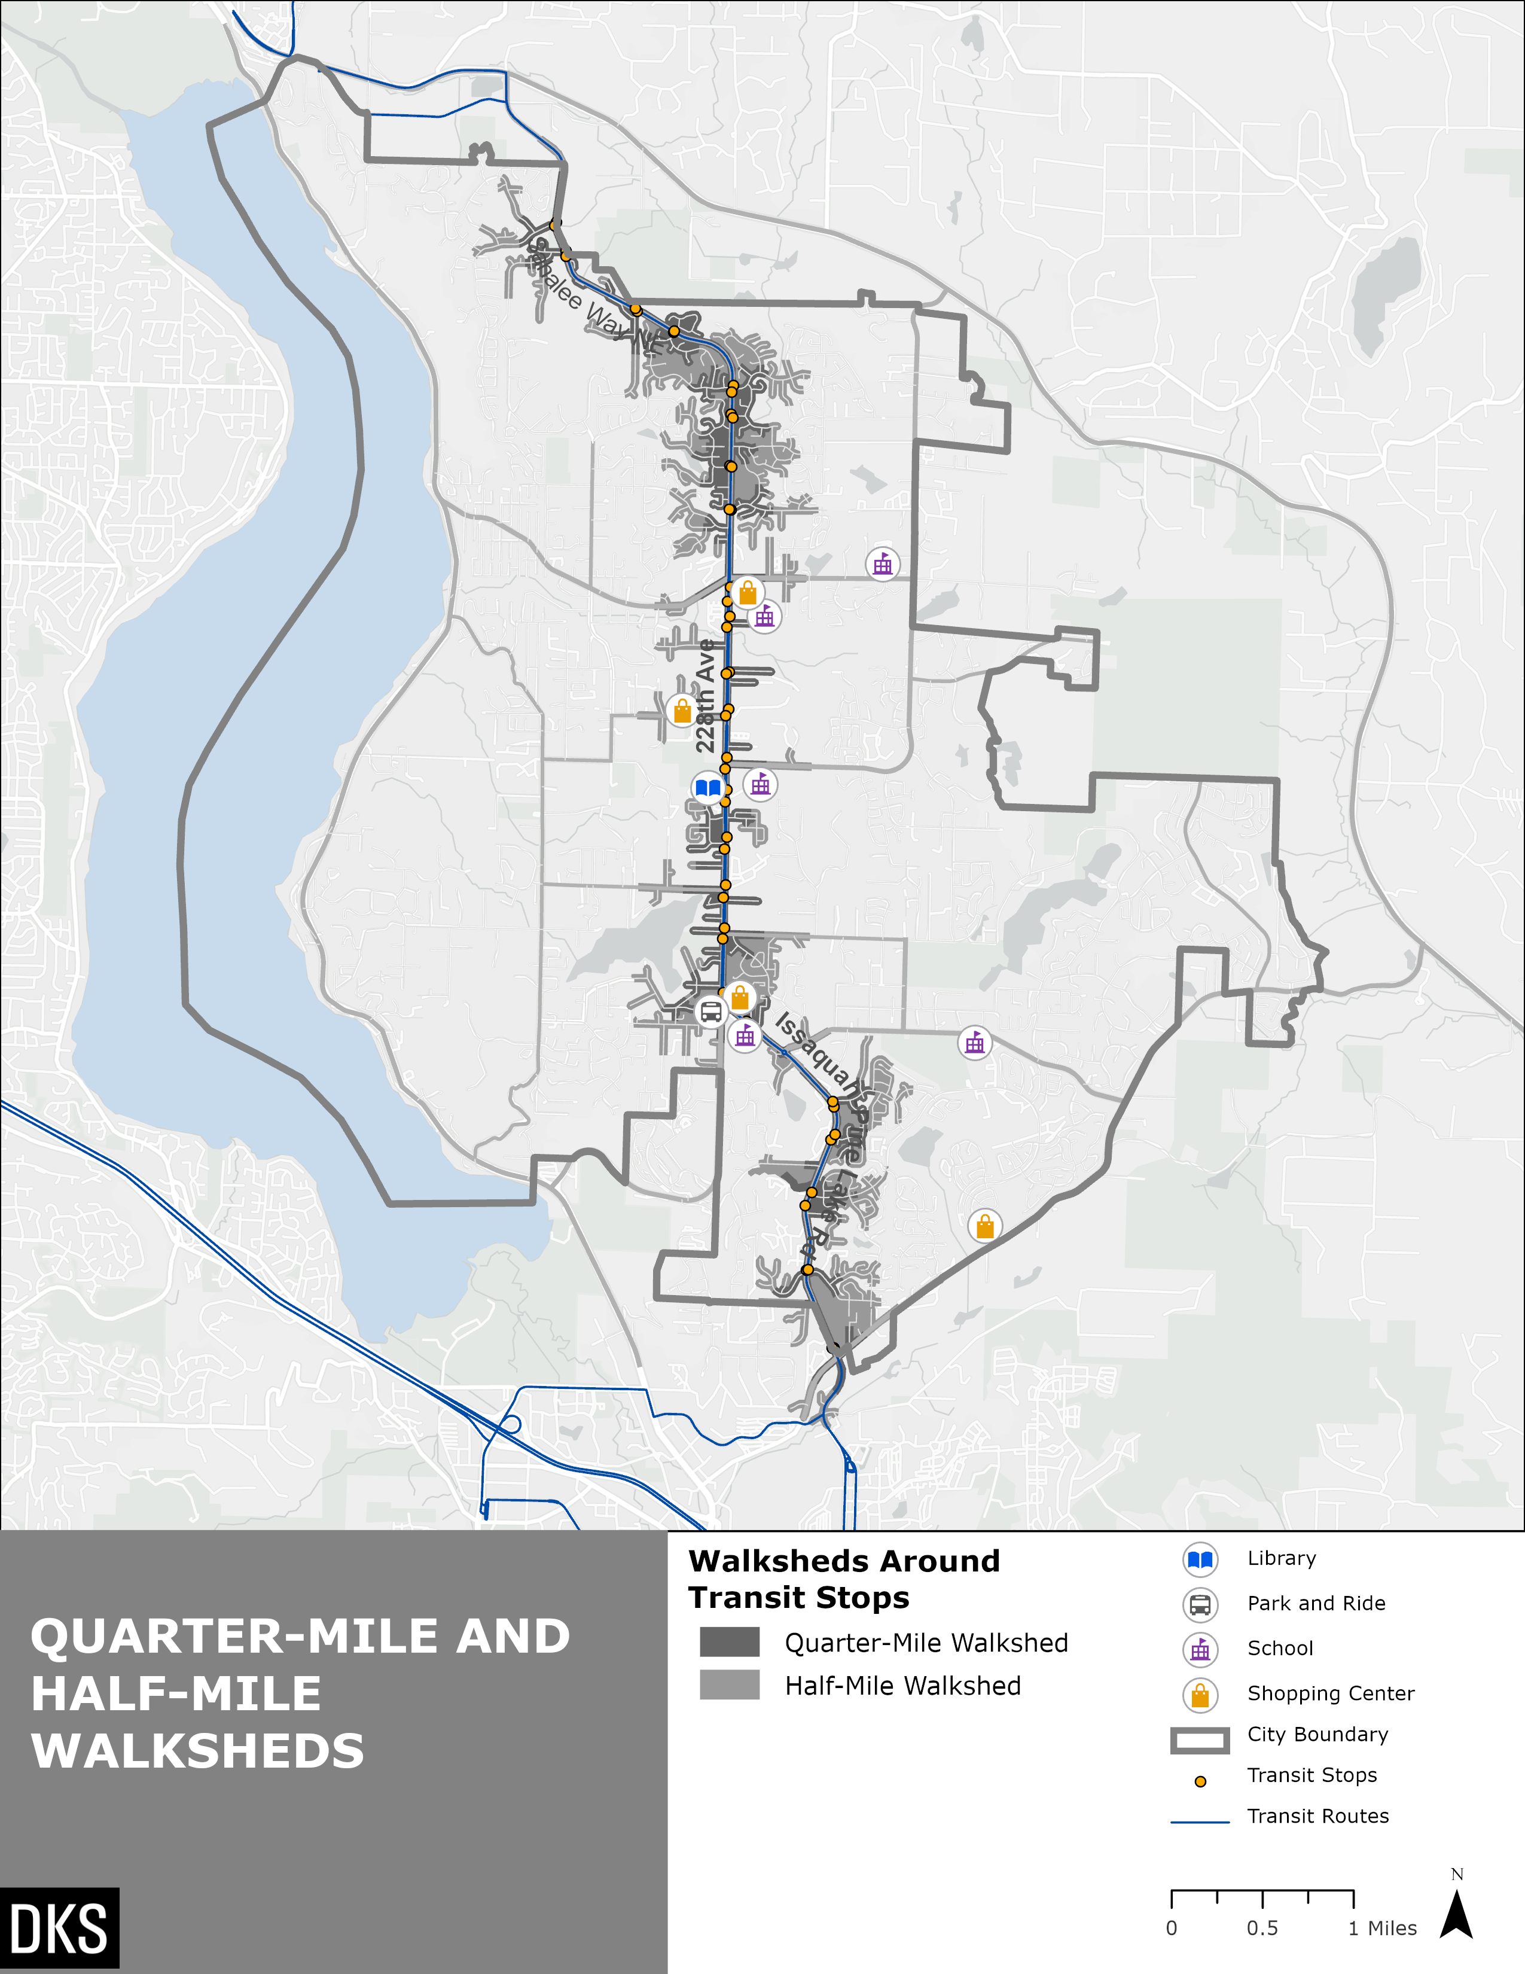
Figure 20: transit stops with ¼ mile and ½ mile walkshed
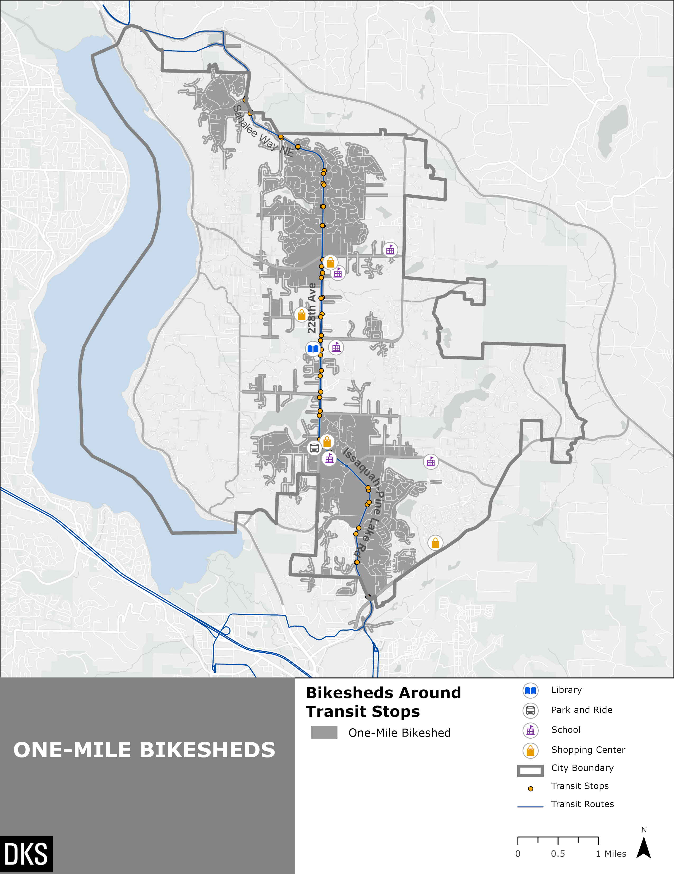
Figure 21: transit stops with 1-mile bikeshed
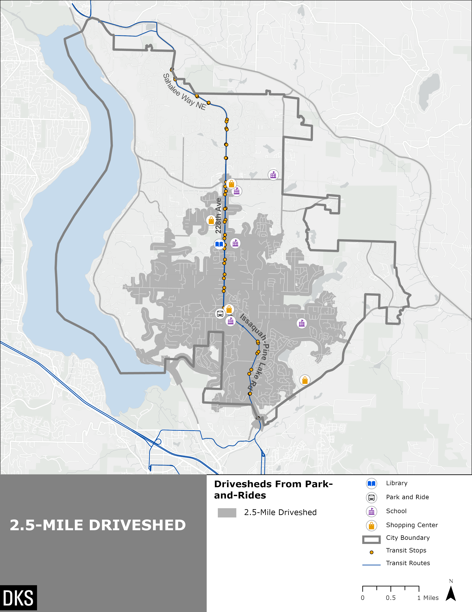
Figure 22: Park and Ride with driveshed

Park and Ride vehicle parking occupancy data was collected from the Puget Sound Regional Council (PSRC) data dashboard. The South Sammamish Park and Ride, which serves all three Sammamish transit routes, has 265 available spaces. In 2021, the average daily occupancy was only 6, equivalent to 2% occupancy. This was down significantly from 2019, where it was typically 54% full and 2016, where it was typically 48% full.
Although not shown in Figure 22, the Issaquah Highlands Park and Ride, which is located less than one mile south of the Sammamish city limits, may be used by Sammamish residents. The majority of Sammamish residents live more than a 2.5-mile drive from this Park and Ride. This Park and Ride provides service to King County Metro Routes 216, 218, 269, and Sound Transit Route 554. This may be especially competitive for Sammamish residents who take Sound Transit Route 554, as this Park and Ride provides all day, 30-minute service, whereas the South Sammamish Park and ride provides only peak hour service. The Issaquah Highlands Park and Ride has 1,010 available parking spaces and was typically 8% occupied in 2021.
Both Park and Rides also have BikeLink on-demand lockers available for secure bike parking. BikeLink is a long-term bike parking company which allows transit users to electronically reserve a bike storage locker on-demand on a first come, first served basis. Rental cost is 5 cents per hour. The parking is for customers’ personal bikes and scooters when connecting to transit, and not for long-term storage.

Key Takeaways – Access to Transit
Throughout Sammamish, most residents do not live within walking distance of a bus stop. Most jobs in Sammamish are not located within walking distance of a bus stop, although jobs are more likely than households to be close to transit. About 35% of the population live within a comfortable biking distance of a bus stop. About 37% of the population lives within a 2.5-mile drive of the South Sammamish Park and Ride. The South Sammamish Park and Ride typically has significant capacity available. The Issaquah Highlands Park and Ride is also an option for Sammamish residents, and typically has significant capacity available.
The shares of people of color, low-income people, and zero-vehicle households are fairly evenly spread out throughout the City. Therefore, these minority groups are not more or less likely to live within walking distance of transit than the population overall, as shown in Table 3.

Transit and Auto Travel Time Comparisons
Google Maps was used to understand travel time between different regional and local activity centers within Sammamish. Travel time between transit and driving was compared, which helps understand how attractive transit would be for trips to and from Sammamish, as well as within Sammamish. Travel time was sampled for a typical Tuesday at 4 pm for local trips and regional trips to Sammamish. Regional trips from Sammamish were sample for a typical Tuesday at 7 am. The times were chosen to represent a typical peak hour commute. Note that transit time includes walking time from the origin/destination to the stops and includes transfer times (if required); origin and destination points were selected to be relatively close to a transit stop near each activity center, to the extent possible.
It is important to note that trips to and from the Providence Point senior center include a walking time of 23 minutes between the approximate center of Providence Point and the closest transit stop which is the South Sammamish Park & Ride. However, while this walking distance is technically feasible, it requires walking along roadways that do not have sidewalks and therefore pose potential safety risks, and pedestrians are unlikely to walk this route. Despite these conditions, the travel time analysis below for transit trips to and from Providence Point is presented using this 23 minute walking time to highlight that the Providence Point community is not well served by fixed route bus service as compared with personal vehicle trips.
The transit-auto travel time ratio metric is calculated by dividing the transit travel time by the auto travel time for a given origin-destination pair. These ratios are shown in Table 4 for regional trips, and color coded in Table 5 for local trips. Generally, a ratio of 1.5 is tolerable for choice riders and anything above 2.0 is tedious for all riders.

Regional Trips
Figure 23 and Table 4 summarize average and maximum transit/auto travel time ratio as well as travel time between ten local activity centers or neighborhoods within Sammamish and 11 regional activity centers. Although the transit travel times do not include waiting time, the map illustrates the average headway to indicate how long a passenger who did not consult a schedule or bus arrival information could have to wait.
For the regional trips that were sampled:
- The average regional transit trip takes 2.5 times longer than driving.
- The average regional transit trip to Sammamish takes at least 1.3 times longer than driving and takes at most 4.4 times longer (for trips from Providence Point to North Bend Park & Ride).
- The average regional transit trip from Sammamish takes at least 1.7 times longer than driving and takes at most 6.5 times longer (for trips from Providence Point to North Bend Park & Ride).
- Note that trips to and from Providence Point include an approximate 23-minute walk to/from the South Sammamish Park & Ride. This route lacks sidewalks in some areas and is not considered feasible. This data is included to show that the route is not competitive with driving.

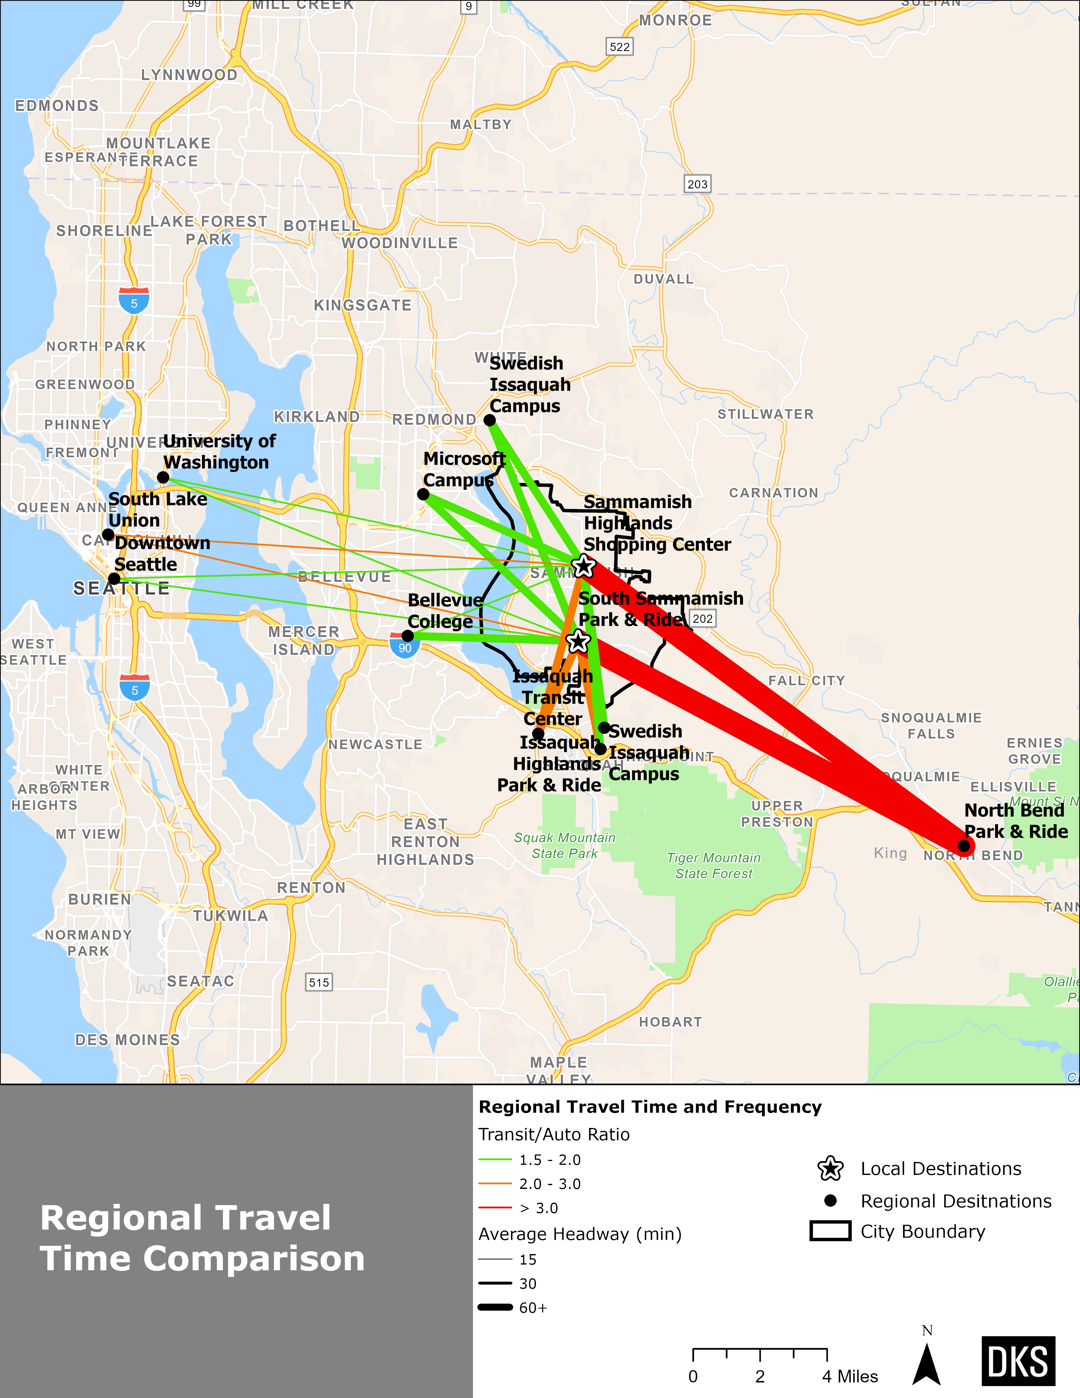
Figure 23: Travel Time Comparisons for Sample Regional Trips to/From Sammamish, Ratio of Scheduled Transit to Projected Auto Time at Tuesday, 7 AM from Sammamish 4 pm to Sammamish based on Google Trip Planner
Table 4 REGIONAL TRANSIT AND AUTO TRAVEL TIME COMPARISONS
 | From Regional Location to Sammamish (4 pm) |  |  |  | From Sammamish to Regional Location (7 am)
Regional Activity Center | Avg Transit -Auto Travel Time Ratio | Max Transit- Auto Travel Time Ratio | Avg Auto Travel Time (Min) | Avg Transit Travel Time (Min) | Avg Transit -Auto Travel Time Ratio | Max Transit- Auto Travel Time Ratio | Avg Auto Travel Time (Min) | Avg Transit Travel Time (Min)
Issaquah Highlands P&R | 2.3 | 3.9 | 12 | 26 | 2.7 | 4.2 | 11 | 28
Issaquah Transit Center | 2.3 | 4.0 | 16 | 35 | 3.3 | 4.9 | 14 | 43
Swedish Medical Center - Issaquah | 2.1 | 3.1 | 15 | 32 | 2.6 | 4.0 | 14 | 36
North Bend P&R | 3.3 | 4.4 | 29 | 92 | 5.3 | 6.5 | 28 | 143
Bellevue College | 1.7 | 2.6 | 24 | 39 | 2.5 | 3.9 | 18 | 43
Redmond Microsoft Campus | 1.8 | 2.3 | 25 | 45 | 2.2 | 3.1 | 21 | 47
Swedish Medical Center – Redmond | 1.9 | 2.5 | 19 | 37 | 2.2 | 3.1 | 18 | 41
Downtown Seattle (3rd Ave & Madison St) | 1.7 | 2.4 | 36 | 59 | 2.1 | 2.9 | 31 | 63
Seattle U District | 1.7 | 1.9 | 46 | 78 | 2.3 | 3.1 | 36 | 85
South Lake Union (Westlake Ave N & Mercer St) | 2.9 | 3.2 | 31 | 89 | 2.4 | 3.3 | 33 | 77
Source: Travel times from Google Maps trip planner for a typical Tuesday at 7am for trips from Sammamish and 4pm for trips to Sammamish

Local Trips
Figure 24 and Table 5 represent transit travel times between four different locations within Sammamish (and Providence Point in Issaquah) using a map and an origin-destination matrix, respectively. Although the transit travel times do not include waiting time, the map illustrates the average headway to indicate how long a passenger who did not consult a schedule or bus arrival information could have to wait.
For the local transit trips that were sampled within Sammamish, the average transit trip takes 2.4 times longer than driving.
- Transit trips to/from Providence Point, have comparatively high transit-to-auto travel time ratios (3.0–4.4) as these trips include an approximate 23-minute walk to/from the South Sammamish Park & Ride. This route lacks sidewalks in some areas and is not considered feasible. This data is presented to show that the route is not competitive with driving.
- For all trips between origins and destinations not including Providence Point, transit travel times were less than twice as long as driving.

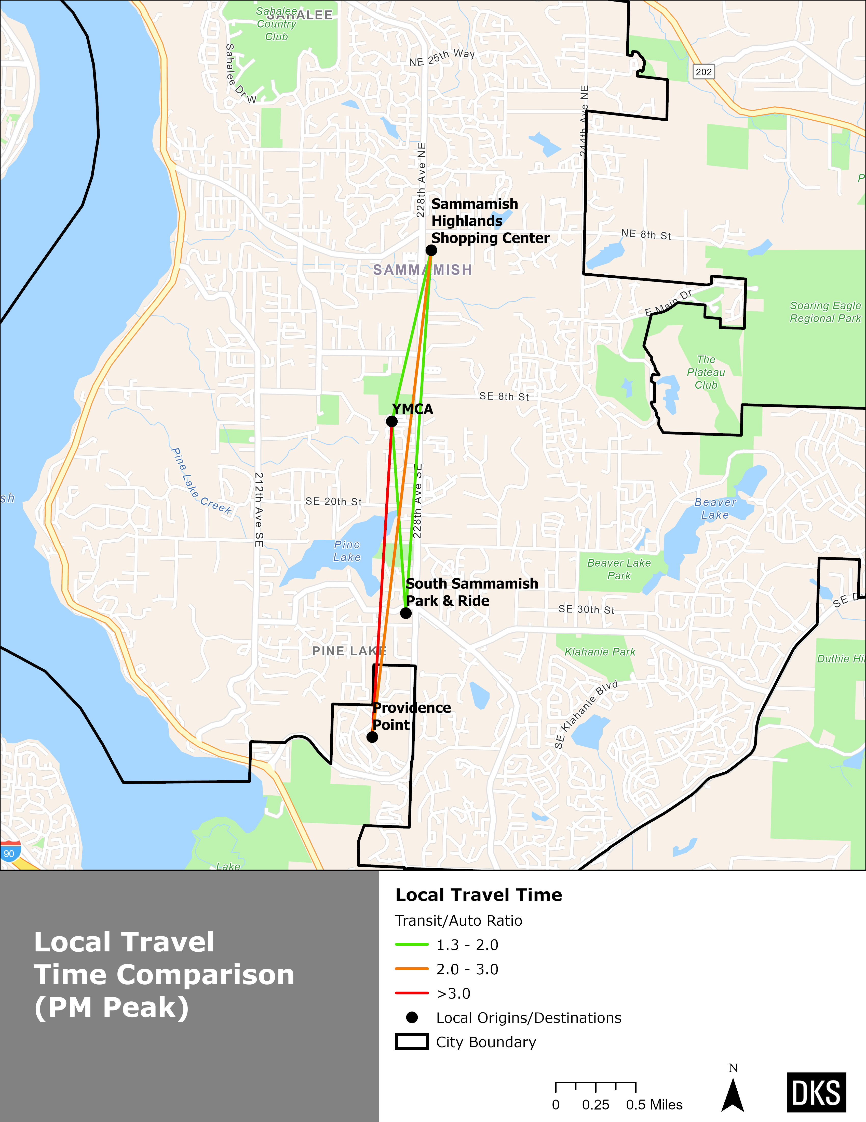
Figure 24: Travel Time Comparisons for Sample Local trips within Sammamish, Ratio of Scheduled Transit to Projected Auto Time at Tuesday, 4 pm based on Google Trip Planner
Tables 5 shows various transit-auto travel time ratios using the color-coded scale below:
CATEGORY | COLOR CODED RANGE
GOOD | <= 1.5
ACCEPTABLE | >1.5 AND <=2.0
MODERATELY HIGH | >2.0 AND <=3.0
HIGH | >3.0 AND <=4.5

The values in Table 5 represent transit travel time in minutes between origin and destination pairs. The colors in Table 5 correspond to transit to auto travel time ratios according to the above key.
Table 5 Transit Travel Times between Origin-Destination Pairs, Transit Travel Time and TraNsit-To-Auto Travel Time Ratio
Destination  Origin | South Sammamish P&R | YMCA | Providence Point¹ | Sammamish Highlands shopping mall
South Sammamish P&R | - | 10 | N/A | 12
YMCA | 9 | - | 32 | 6
Providence Point¹ | N/A | 33 | - | 34
Sammamish Highlands shopping mall | 13 | 11 | 36 | -
Notes: The values in the table represent transit travel time in minutes between origin and destination pairs. The colors correspond to transit to auto travel time ratios according to the key above. Connections identified as N/A and highlighted in gray indicate a trip in which there is no feasible transit route between the origin-destination pair. 1: Providence Point does not have a transit route. This travel time includes a 23-minute walk to the South Sammamish Park and Ride on a route lacking sidewalks, which is not considered feasible. This data is presented to show that the route is not competitive with driving.

Key Takeaways – Transit Travel Time
- Traveling to and from regional destinations on transit can take significantly longer than driving depending on your origin and destination.
- The most competitive transit trips in the afternoon were from Bellevue College, Swedish Medical Center – Redmond, and downtown Seattle (1.7-1.9 times longer on transit, on average). The least competitive trips are those from North Bend Park & Ride (3.3 times longer, on average).
- In the morning, trips tend to take 2-3 times longer from Sammamish to regional locations. North Bend is an outlier and tends to take significantly longer than driving (5.5 times longer on average). Transit headways to and from North Bend are generally more than 60 minutes. Various other destinations like Issaquah Transit Center or the Microsoft Redmond Campus took 2 to 3 times longer in most cases.
- Because the majority of primary destinations within Sammamish are along corridors which have existing bus service, transit travel times between some local origins and destinations can be relatively short – 10 to 15 minutes – and may take only 1.5 times longer than driving. Trips to and from Providence Point had the highest transit-auto travel time ratios due to the long walking time needed to access the nearest transit stop. It is important to note that this walking trip between Providence Point and South Sammamish Park & Ride is likely prohibitively unsafe for the majority of residents due to the lack of sidewalks along the roadways which connect them. Therefore, fixed route bus service is virtually unreachable by walking for those living within Providence Point.

Transit operational performance
The following measures were used to assess transit speed and reliability for transit service in Sammamish. Because all trips are outside of the peak hour in the early morning or late evening, Route 554 showed little to no delay in Sammamish and is excluded from this analysis.
- Bus Segment Delay measures travel time variability, or the additional time a transit trip takes beyond a free-flow speed. There may be various causes for delay, including traffic congestion. Bus delay is estimated based on travel time statistics collected by Metro across a sample of all bus trips within a service period (in this case, Fall 2021). Dwell time, or the time buses spend picking up and dropping off passengers, is excluded from delay statistics.
- Passenger Delay measures the total delay experienced by people riding transit. It is calculated by multiplying the delay on each bus trip by the number of people on board the bus and helps understand where delay impacts the most people.
Figures 25 and 26 illustrate total daily bus delay per mile for Routes 216 and 269, respectively, on different segments of the bus network in Sammamish. The measure is based on delay for all bus trips that serve each segment, normalized for distance to allow comparison across different segments. The delay scales of the two figures are the same for easy comparison.
Figures 27 and 28 illustrate total daily passenger delay per mile for Route 216 and 269 respectively, on different segments of the bus network in Sammamish. The measure is similar to bus delay but delay is weighted by the number of people onboard each bus on each segment, that experience the delay. The delay scales of the two figures are the same for easy comparison.
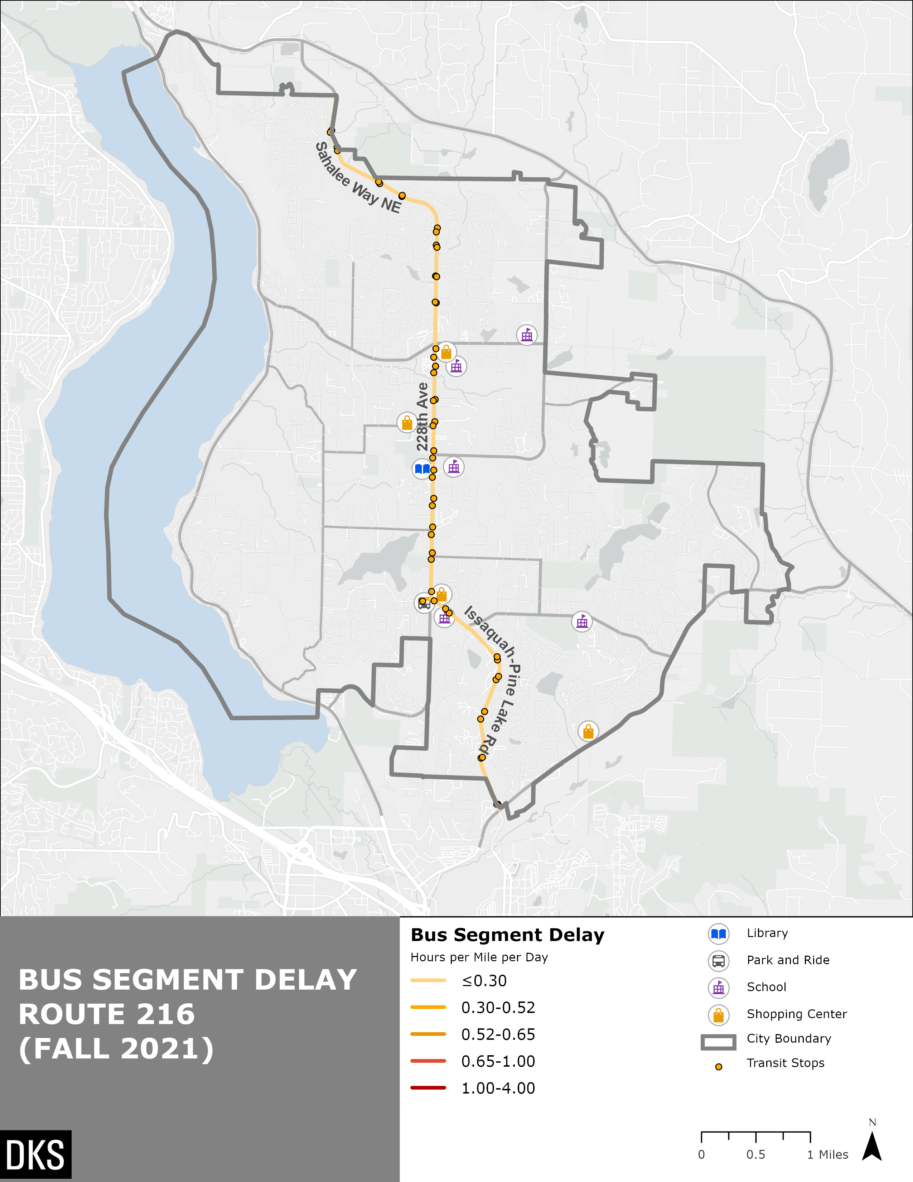
Figure 25: Map of Bus Segment Delay Route 216
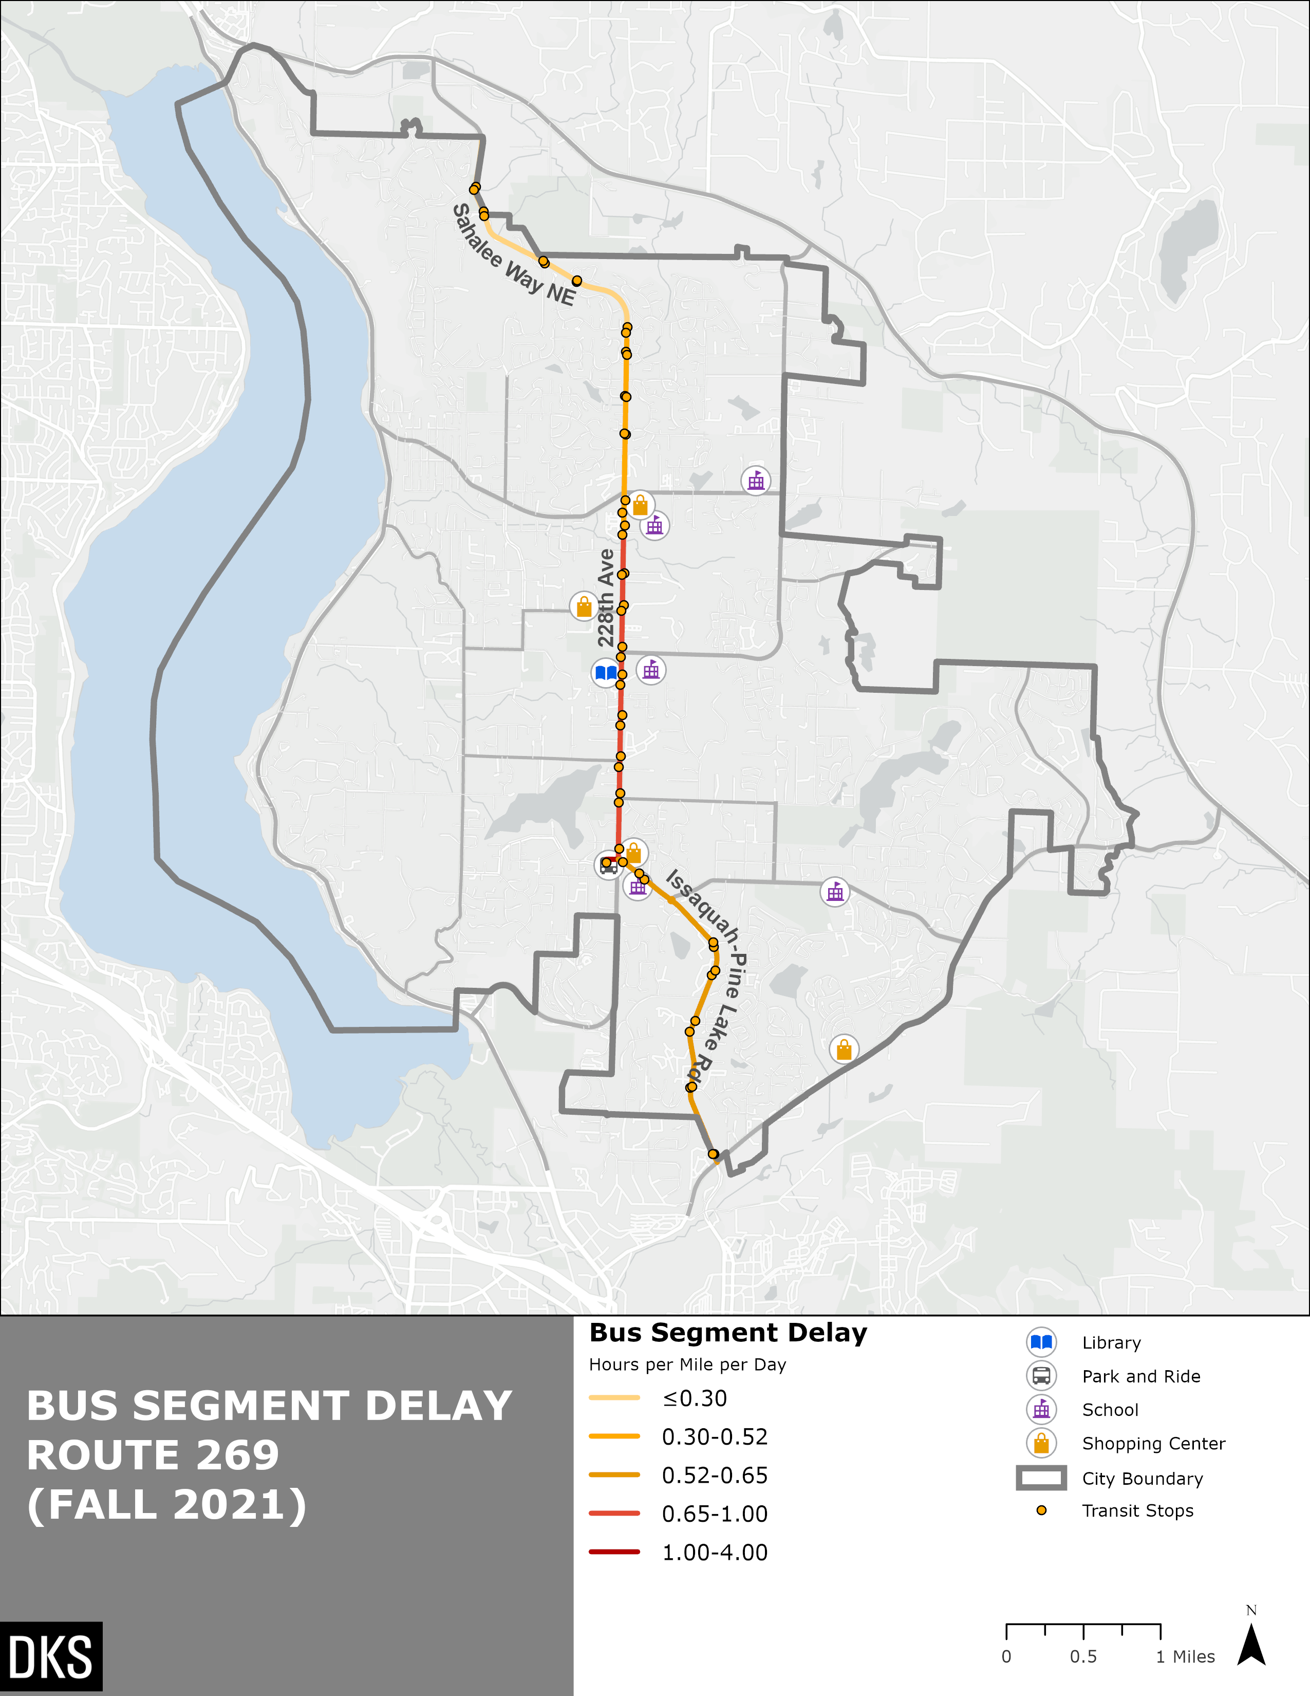
Figure 26: Map of Bus Segment Delay Route 269
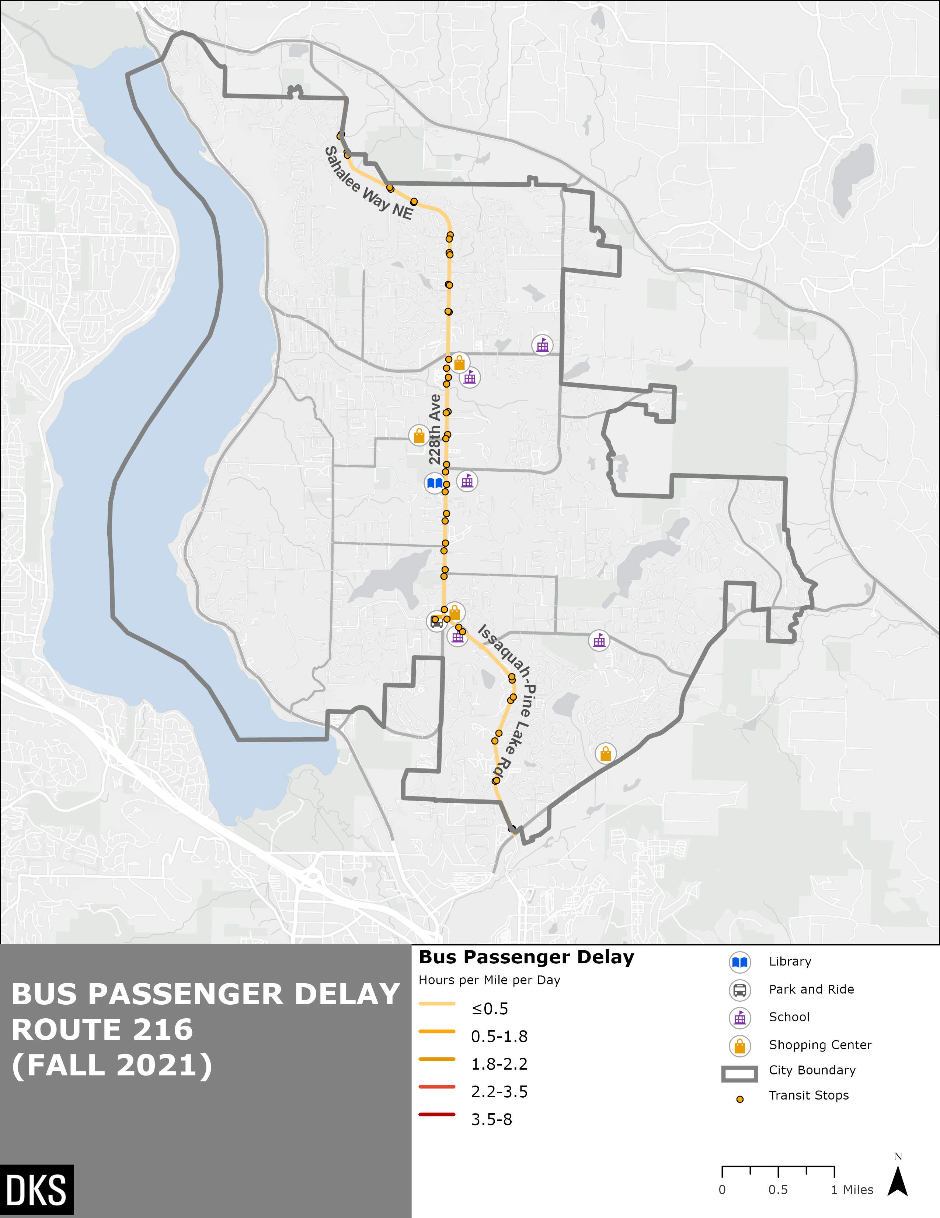
Figure 27: Map of Passenger Delay Route 216
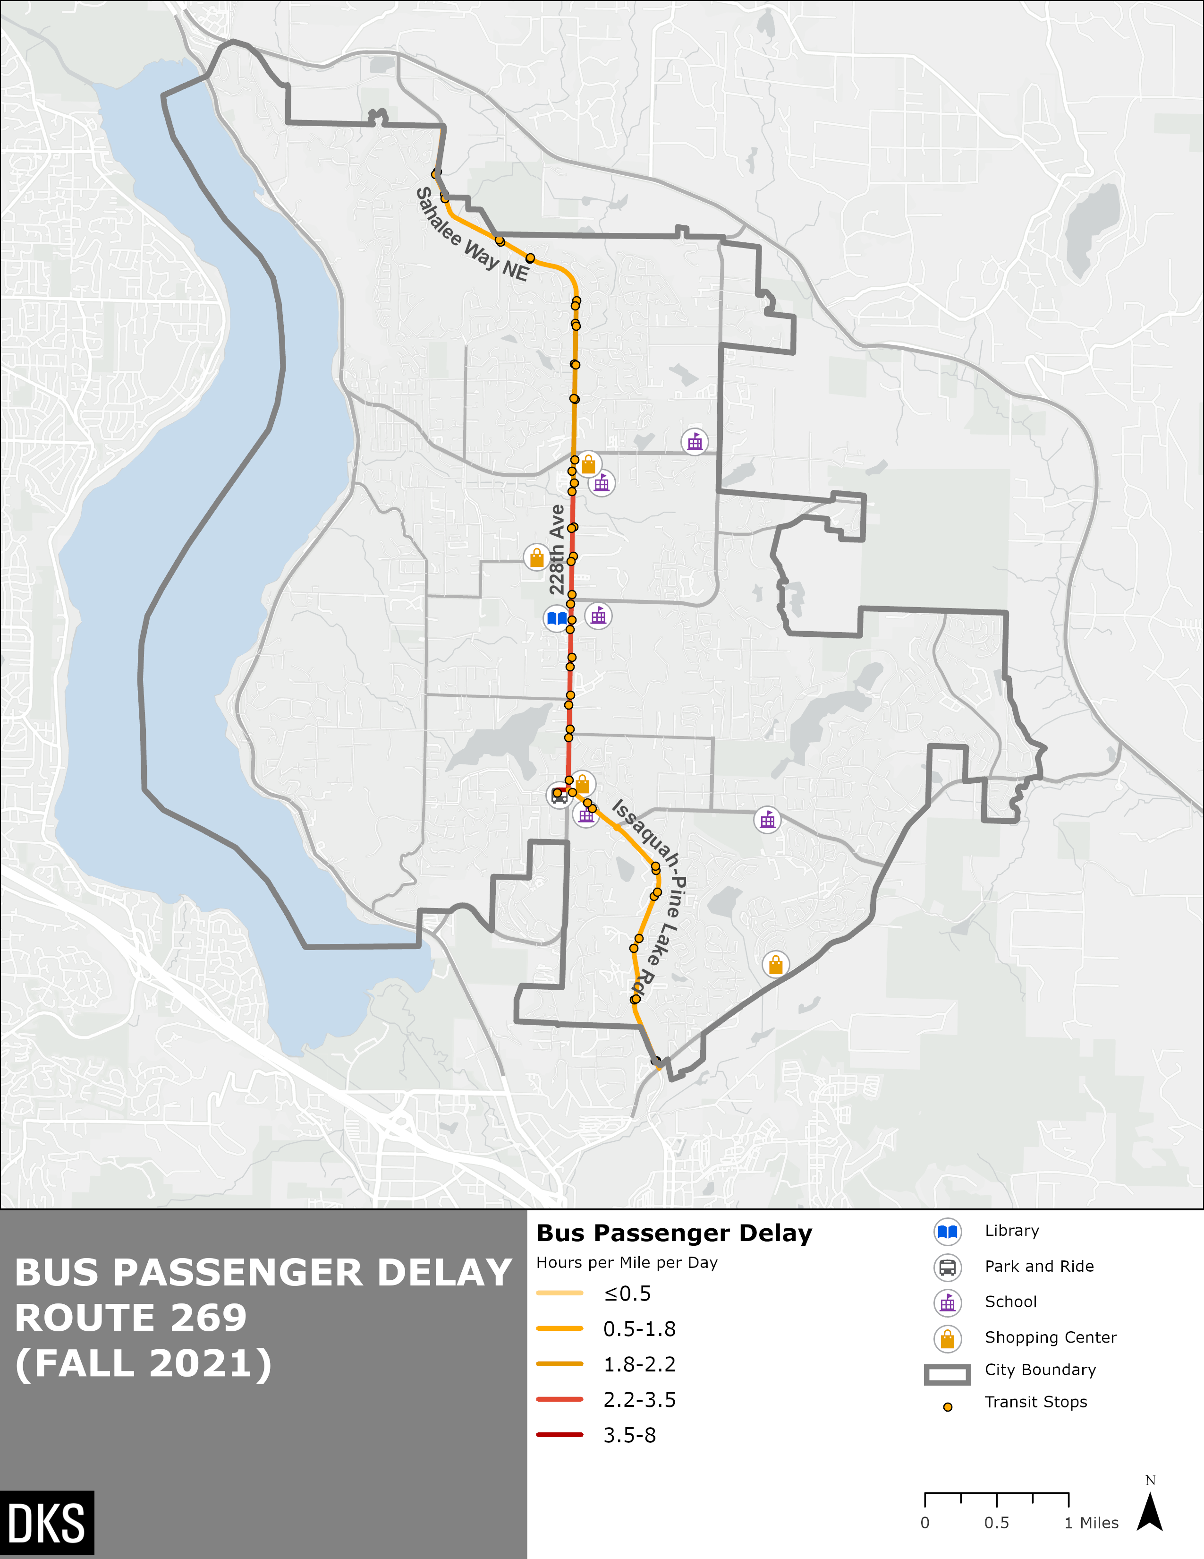
Figure 28: Map of Passenger Delay Route 269

Key Takeaways – Transit Operational Performance
Route 216 showed little delay compared to Route 269. Route 269 runs more often than Route 216 and tends to experience more delay when compiled throughout the typical day. The most delay tends to come from circulating the South Sammamish Park and Ride. Additional delay occurs on 228th Avenue SE between the Park and Ride and NE 8th Street. This area of 228th Avenue NE is generally the most congested area of Sammamish, as it is the only north-south connecting arterial in the City.

Conclusion
The extent of fixed-route transit in Sammamish is three bus routes along 228th Avenue SE and Issaquah-Pine Lake Road, each with varying levels of frequency. Route 216, which provides service to Seattle and Redmond, operates only during the peak hours and only in the peak direction. Route 269, which provides service to Issaquah and Redmond, operates with 30 to 45 minute headways throughout the day. Route 269 could be used to connect to other transit routes that provide service to Seattle and other key destinations. Route 554 is operated by Sound Transit and has all-day service from Seattle to Issaquah but only has limited service in the evening, late night, and early morning through Sammamish. Excluding work from home, about 7.5 percent of Sammamish commuters use transit to get to work. There is currently no fixed route bus service on weekends in Sammamish. In addition to fixed route service, Metro Flex provides on-demand rides within a certain area of Sammamish on weekdays and Saturdays. This service could be used to make local trips, or it could be used as a first-last mile connection to the South Sammamish Park and Ride. Metro Flex had 78 average daily rides in April 2023.
In 2022, there was an average of 278 weekday boardings on fixed-route service in Sammamish. The busiest transit stops are located near the intersection of 228th Ave SE and NE 8th Street. This is located near Eastlake High School and Sammamish Highlands shopping center. The most recently available Park and Ride data from 2021 showed very low occupancy (2%) at the South Sammamish Park and Ride. There was a significant decrease in both ridership and Park and Ride occupancy between 2019 and 2022 due to the COVID-19 pandemic.
While there is a market for transit in Sammamish, some obstacles exist. Nearly 25% of Sammamish workers work from home. Currently, nearly 80% of non-work from home workers drive alone to their jobs. A major obstacle is access to transit. Only about 6% of the population lives within a quarter mile of a bus stop, although 37% are within a 2.5-mile drive of the South Sammamish Park and Ride. Demographic data show that low-income residents, people of color, and zero-car households have about the same likelihood of being within a quarter mile of transit as compared with the overall population.
Another obstacle is travel time. Transit trips among destinations within Sammamish tend to take at least 1.5 times longer than driving. The majority of the destinations analyzed are along the bus routes. However, for regional trips, transit tends to take longer than driving, generally about 2-3 times longer depending on the location and time of day, which may discourage some users.

https://aspe.hhs.gov/topics/poverty-economic-mobility/poverty-guidelines
National Academies of Sciences, Engineering, and Medicine. 2013. Transit Capacity and Quality of Service Manual, Third Edition. Washington, DC: The National Academies Press. https://doi.org/10.17226/24766
Park and Ride Planning and Design Guidelines (Spillar, 1997),
National Academies of Sciences, Engineering, and Medicine. 2013. Transit Capacity and Quality of Service Manual, Third Edition. Washington, DC: The National Academies Press. https://doi.org/10.17226/24766

